A

*Mobile banking*

*Management System*

a sql project

FALL 2022

Introduction To Database [SECTION- N]

DATE OF SUBMISSION: 26 Dec, 2022

**ProJect Title :** mobile banking management system

**Submitted by**

**GROUP: 1**

|  |  |
| --- | --- |
| **NAME** | **ID** |
| SHAFIN, TAFSIRUL ISLAM | **22-47325-1** |
| ISLAM, MD. MANSUR | **22-46550-1** |
| BUSHRA, ASIF | **22-46388-1** |
| ALAM, SHADMAN SHAKIB | **22-46262-1** |

**instructed by**

***RIFAT IBN ALAM***

###### Faculty of, Computer Science

AMERICAN INTERNATIONAL UNIVERSITY – BANGLADESH

*TABLE OF CONTENTS*

|  |  |
| --- | --- |
| * SCENARIO |  |
| * ER DIAGRAM BASED ON SCENARIO |  |
| * NORMALIZATION OF ER DIAGRAM |  |
| * TABLE CREATION WITH SCENARIO |  |
| * DATA INSERTION      * JOINING      * SUBQUERY      * VIEW |  |
| * CONSTRAINTS ADDING |  |
| * QUERY WRITING |  |

*SCENARIO*

# Introduction:

Mobile banking is one of the latest tools for easy and convenient banking in the current world. Day by day mobile banking is becoming popular in Bangladesh. With proper guidelines, mobile banking can take Bangladesh to a different level of prosperity. Mobile banking is a digital financial service in the banking sector that facilitates banking via mobile devices. And this mobile banking management system’s primary benefit is that it makes the mobile banking system a lot easier. Reduced a lot of time and make life very comfortable that they can take out money or give money any time they want.

# Scenario Description:

**In a mobile banking system, user can sent money to many another users. And user have attributes like u_id, u_name, u_phonenumber, dob and his or her living place like his or her city and country and another user also have attributes like a_id, a_name and a_phonenumber. A user can pay multiple types of payment in various places like shops, and pay bill in various others like internet bill and electric bill so for that this others and shops has their own attributes like shops has s_id and s_name and o the other side other have attributes like o_id, o_name. A user can withdraw money from various agents and those agent have his own attributes like ag_id and ag_phonenumber. A user may-have multiple accounts and they can log-in to multiple accounts. And accounts has attributes like account_no and balance. User can log-in multiple account and also this account is connected with their bank account but using this bank account they can withdraw their money from any time and any where so bank also have it’s attributes like b_name, b_id. User account is connected with employees this employees maintain their accounts and this employees are connected with a company and a company can have many employees. Company have attibutes like c_id, c_name, and address like city and country. At last company have many bank which connects with them.**

*ER DIAGRAM*

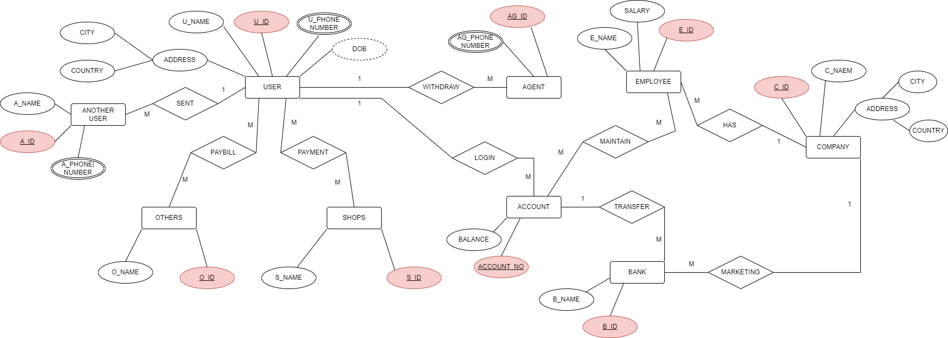

***NORMALIZATION***

**WITHDRAW:**

**This is a one to many relationship**

UNF : address, city ,country, u_name ,u-id ,u_phonenumber ,dob, ag_ phone, ag _id

1NF: city, country, u_name, u-id ,dob, ag_ phone, ag _id

2NF: 1. city, country, u_name, u-id , u_phonenumber ,dob.

2. ag_ phone, ag _id , u-id (FK)

3NF: 1. city, u_name, u-id , u_phonenumber ,dob.

2. ag_ phone, ag _id , u-id (FK)

3. city , country

**MAINTAIN:**

**This is a many to many relationship**

UNF : account_no , balance , e_name, salary, e_id

1NF: account_no , balance , e_name, salary, e_id

2NF:

1.account_no , balance

2. e_name, salary, e_id

3. account-no , e_id(FK)

**3NF: ( same as 2nf)**

1.account_no, balance

2. e_id, e_name, salary

3. account_no, e_id(FK)

**SENT:**

**This a one to many relationship**

UNF: u_name, u_phonenumber, dob, u_id, address, city, country, a_phonenumber, a_id, a_name

1NF: u_name, dob, u_id, city, country, a_id, a_name

2NF:

1. city, country, u_name, u-id , u_phonenumber ,dob.
2. a_phonenumber, a_id, a_name, u_id (FK)

3NF:

1. city, u_name, u-id , u_phonenumber ,dob.
2. A_phonenumber, a_id, a_name, u_id (FK)
3. City, country

**PAYBILL:**

**This is a many to many relationship**

UNF: u_name,u_phonenumber,dob,u_id,address,city,country, O_id, O_name

1NF: u_name,dob, u_Id, city, country, O_Id, O_name

2NF:

1. u_name, u_phonenumber, dob, u_id, city, country

2. O_id, O_name

3. u_id, O_id(FK)

3NF:(same as 2NF)

1. u_name, u_phonenumber, dob, u_id, city

2. O_id, O_name

3. u_id, O_id(FK)

**PAYMENT:**

**This is a many to many relationship**

UNF: u_name,u_phonenumber,dob,u_id,address,city,country, s_id, s_name

1NF: u_name, dob, u_Id, city, country, s_Id, s_name

2NF:

1. u_name, u_phonenumber, dob, u_id, city, country

2. s_id, s_name

3. u_id, _id(FK)

3NF:(same as 2NF)

1. u_name, u_phonenumber, dob, u_id, city

2. s_id, s_name

3. u_id, s_id(FK)

**LOGIN:**

**This is a one to many relationship**

UNF: u_name,u_phonenumber,dob,u_id,address,city,country, account_no, balance

1NF: u_name,dob,u_id,city,country, account_no, balance

2NF:

1. U_name,u_phone number,dob,u_id,city,country
2. account_no, balance, u_id (fk)

3NF:

1. U_name,u_phonenumber,dob,u_id,city
2. account_no, balance, u_id (fk)
3. city, country

**TRANSFER:**

**This is a one to many relationship**

UNF: account_no, balance , bank_id, b_name

1NF: account_no, balance, bank_id, b_name

2NF:

1.account_no,balance

2. bank_id, b_name, account_no (FK)

3NF:

1.account_no,balance

2. bank_id, b_name, account_no (FK)

**MARKATING:**

**This is a one to many relationship**

UNF: bank_id, b_name, c_name, c_id, address, city, country

1NF: bank_id, b_name, c_name, c_id, city,country

2NF:

1.bank_id, b_name, c_id(FK)

2. c_name, c_id, city, country

3NF:

1.bank_id, b_name, c_id(FK)

2. c_name, c_id,city

3. city, country

**HAS:**

**This is a one to many relationship**

UNF:e_id, e_name, salary, c_name, c_id, address, city, country

1NF: e_id, e_name, salary, c_name, c_id, city, country

2NF:

1. c_name,c_id,city,country
2. e_name, e_id, salary, c_id (FK)

3NF:

1. c_name, c_id, city
2. e_name, e_id, salary, c_id(FK)
3. city , country.

***FINALIZATION***

**FINAL TABLE:**

1. u-id, u_name, u_phonenumber, city, dob.
2. ag _id, ag_ phonenumber, u-id (FK)
3. city, country
4. account_no, balance
5. e_id ,e_name, salary,
6. account-no, e_id(FK)
7. a_id , a_name ,a_phonenumber, u_id (FK)
8. O_id, O_name
9. u_id, O_id(FK)
10. s_id, s_name
11. u_id, s_id(FK)
12. account_no, balance, u_id (fk)
13. b_id, b_name, account_no (FK)
14. c_name, c_id,city
15. b_id, b_name, c_id(FK)
16. e_name, e_id, salary, c_id(FK)

***LIST OF TABLES***

1. USER1.
2. AGENT.
3. COUNTRY.
4. ACCOUNT.
5. EMPLOYEE.
6. ACC_MAINTAIN.
7. ANOTHER_USER
8. OTHERS.
9. USER_PAYBILL.
10. SHOPS.
11. USER_PAYMENT.
12. USER_LOGIN.
13. BANK.
14. COMPANY.
15. C_BANK.
16. C_EMP.

***TABLE CREATION***

**USER1:**

CREATE TABLE User1 (

u_id INT PRIMARY KEY NOT NULL,

u_name VARCHAR(20) NOT NULL,

u_phonenumber VARCHAR(20) NOT NULL,

city VARCHAR(20) NOT NULL,

dob DATE NOT NULL,

FOREIGN KEY (city) REFERENCES country(city)

);

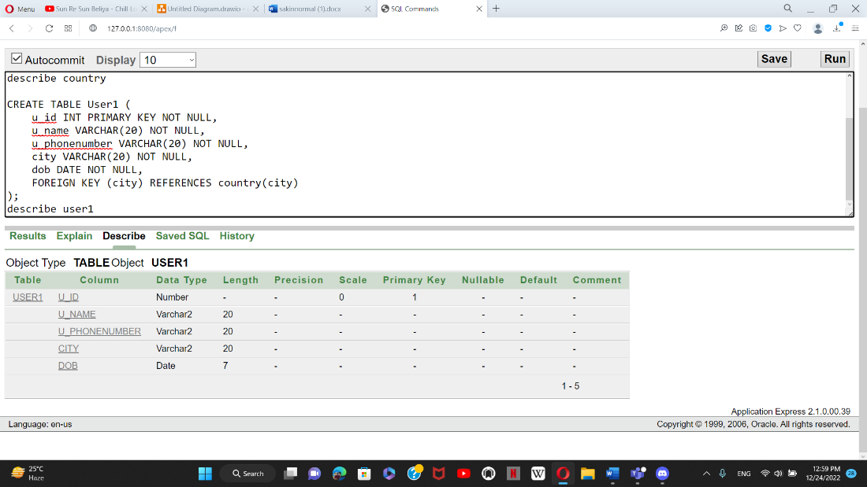

**AGENT:**

CREATE TABLE agent (

ag_id INT PRIMARY KEY NOT NULL,

ag_phonenumber VARCHAR(20) NOT NULL,

u_id int,

FOREIGN KEY (u_id) REFERENCES User1(u_id)

);

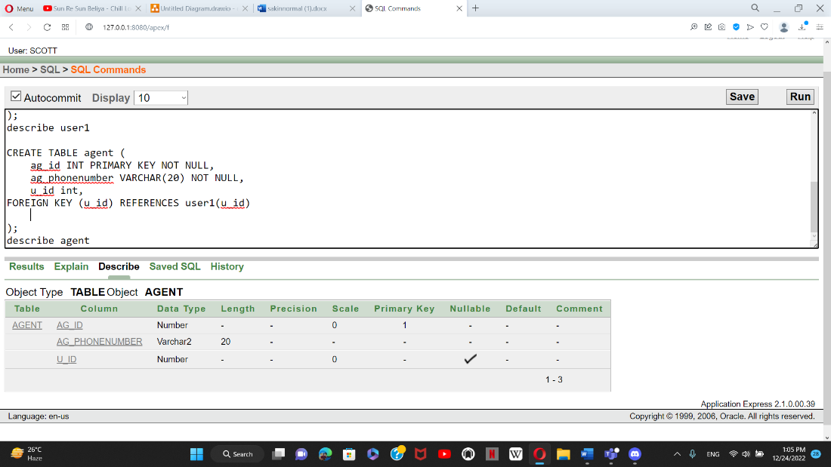

**COUNTRY:**

CREATE TABLE country

city VARCHAR(20) PRIMARY KEY NOT NULL,

country VARCHAR(20) NOT NULL

);

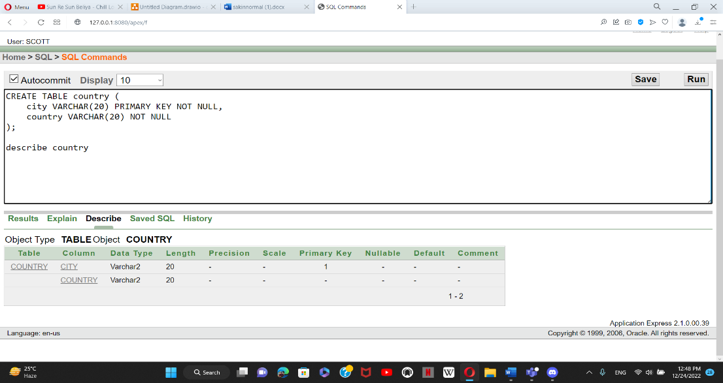

**ACCOUNT:**

CREATE TABLE account (

account_no int PRIMARY KEY NOT NULL,

balance int NOT NULL

);

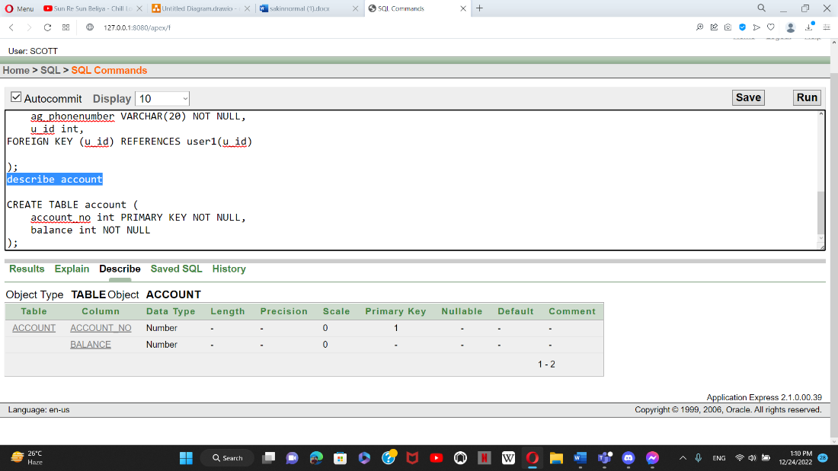

**EMPLOYEE:**

CREATE TABLE employee (

e_id INT PRIMARY KEY NOT NULL,

e_name VARCHAR(20) NOT NULL,

salary int

);

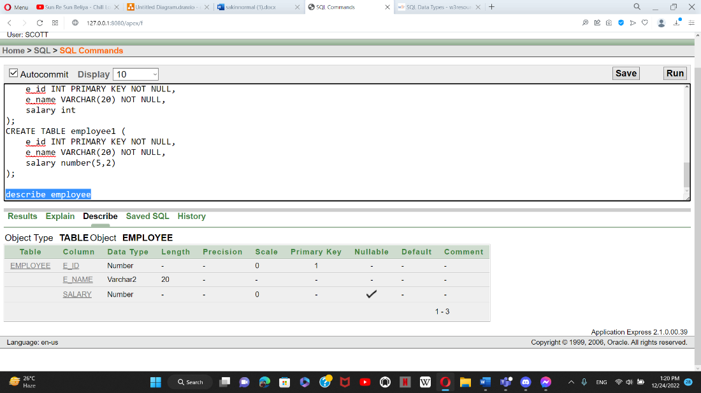

**ACC_MIANTAIN:**

create table acc_maintain(

account_no int primary key not null,

e_id int not null,

FOREIGN KEY (e_id) REFERENCES employee(e_id)

);

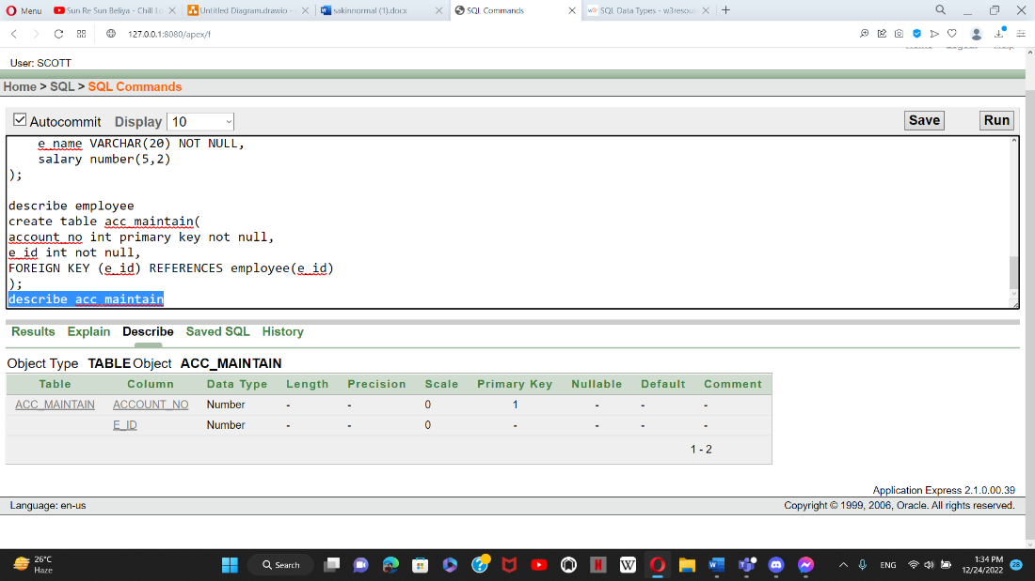

**ANOTHER_USER:**

create table another_user(

a_id int primary key not null,

a_name varchar(20) not null,

a_phonenumber varchar(20) not null,

u_id int not null,

foreign key(u_id) references user1(u_id)

);

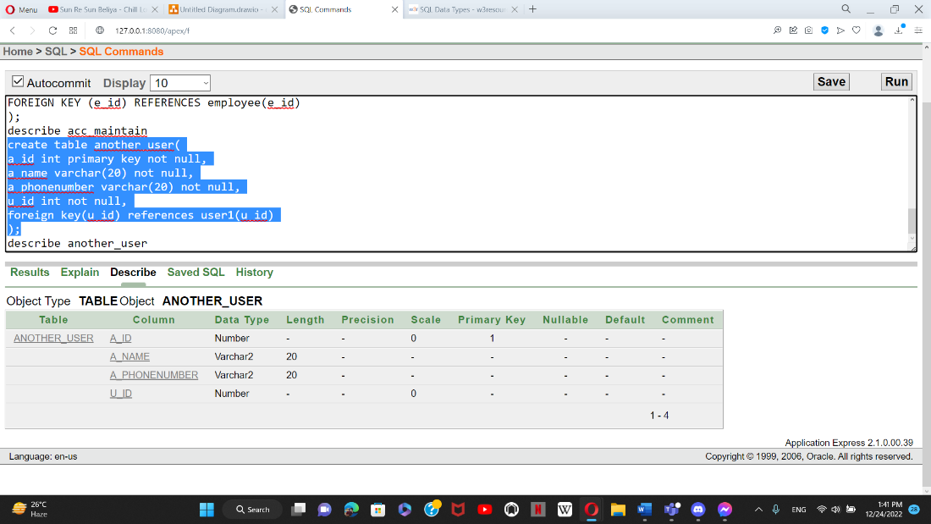

**OTHERS:**

CREATE TABLE others (

o_id INT PRIMARY KEY NOT NULL,

o_name VARCHAR(20) NOT NULL

);

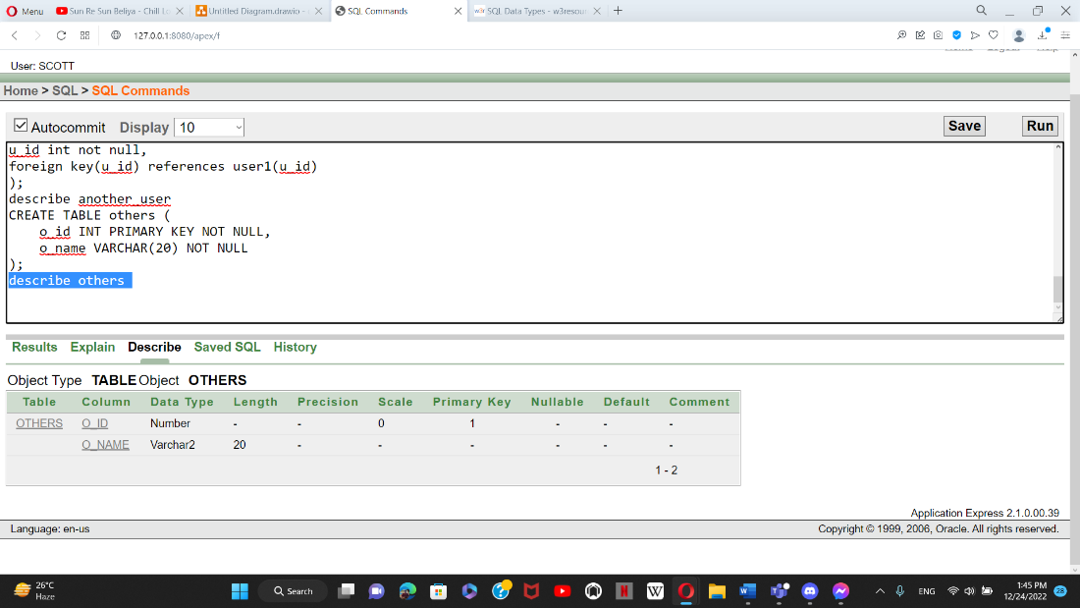

**USER_PAYBILL:**

CREATE TABLE user_paybill (

u_id INT PRIMARY KEY NOT NULL,

o_id INT NOT NULL,

foreign key(o_id) references others(o_id)

);

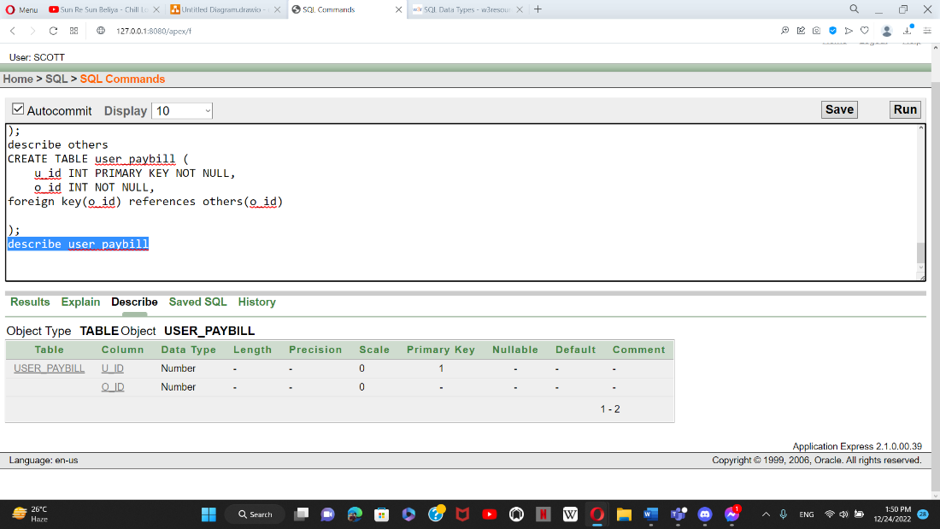

**SHOPS:**

CREATE TABLE shops (

s_id INT PRIMARY KEY NOT NULL,

s_name VARCHAR(20) NOT NULL

);

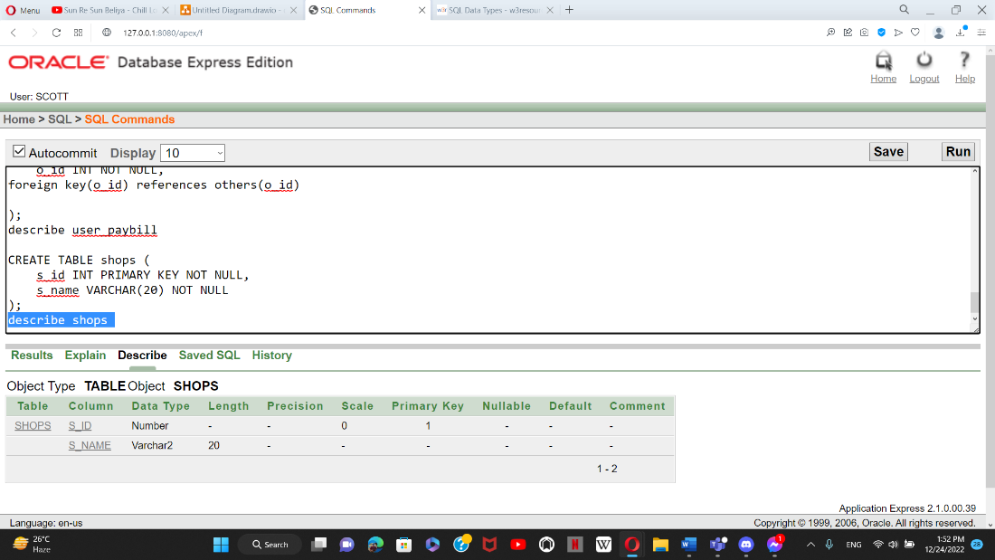

**USER_PAYMENT:**

CREATE TABLE user_payment (

u_id INT PRIMARY KEY NOT NULL,

s_id INT NOT NULL,

foreign key(s_id) references shops(s_id)

);

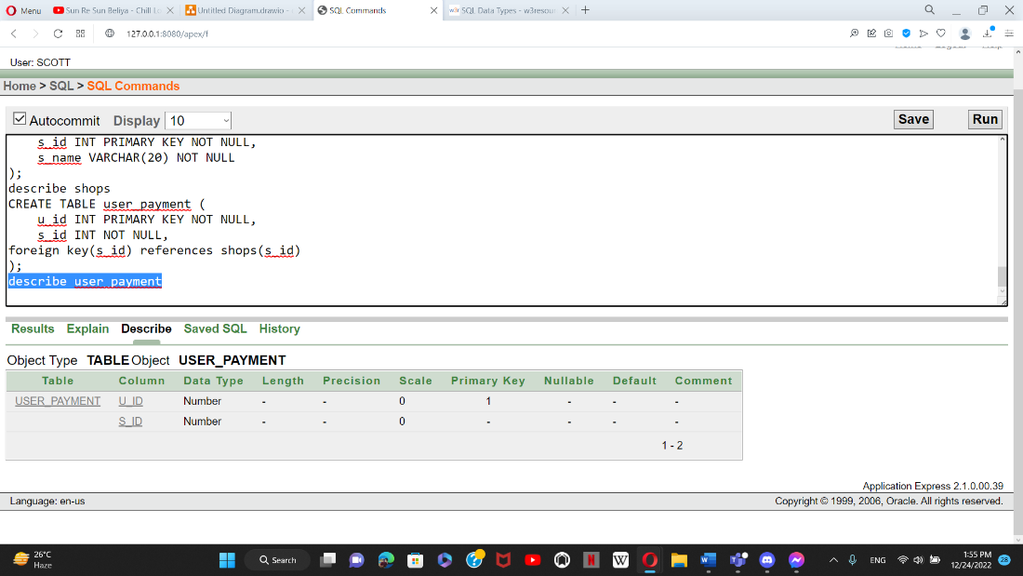

**USER_LOGIN:**

create table user_login(

account_no int primary key not null,

balance int not null,

u_id int not null,

foreign key (u_id) references user1(u_id)

);

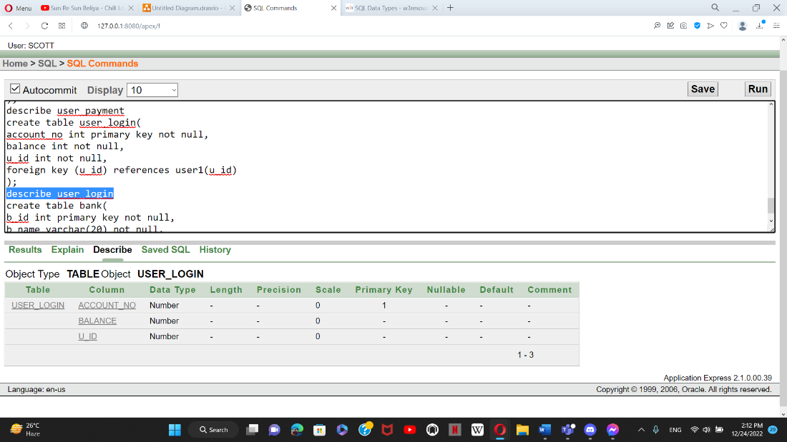

**BANK:**

create table bank(

b_id int primary key not null,

b_name varchar(20) not null,

account_no int not null,

foreign key(account_no) references account(account_no)

);

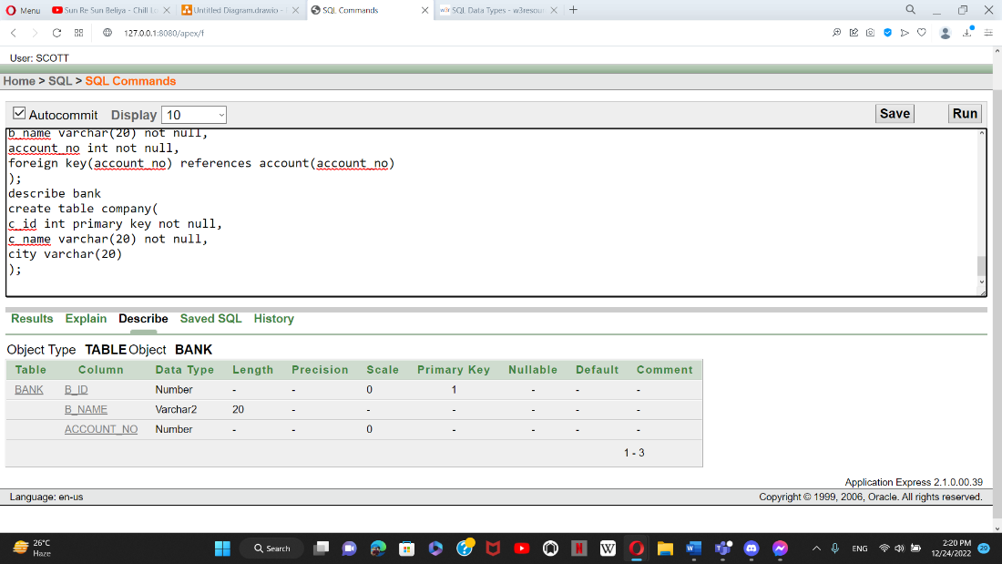

**COMPANY:**

create table company(

c_id int primary key not null,

c_name varchar(20) not null,

city varchar(20)

);

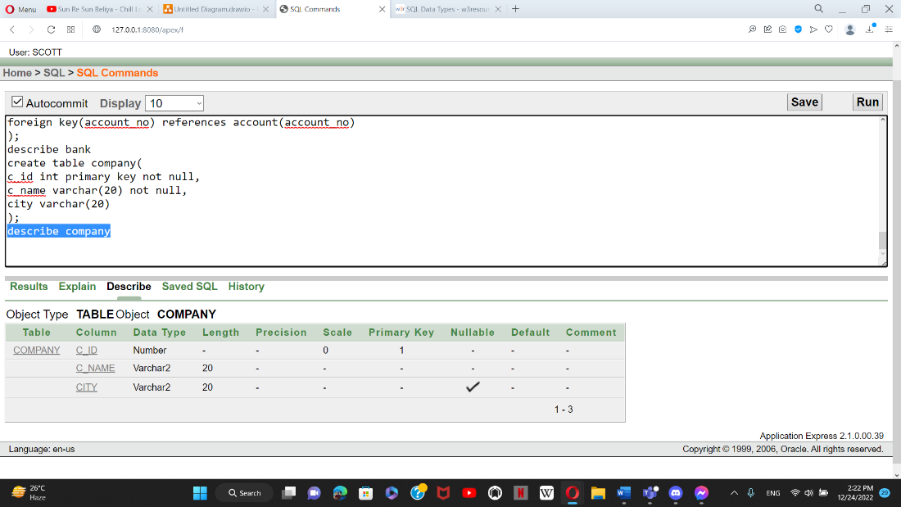

**C_BANK:**

create table c_bank(

b_id int primary key not null,

b_name varchar(20) not null,

c_id int not null,

foreign key(c_id) references company(c_id)

);

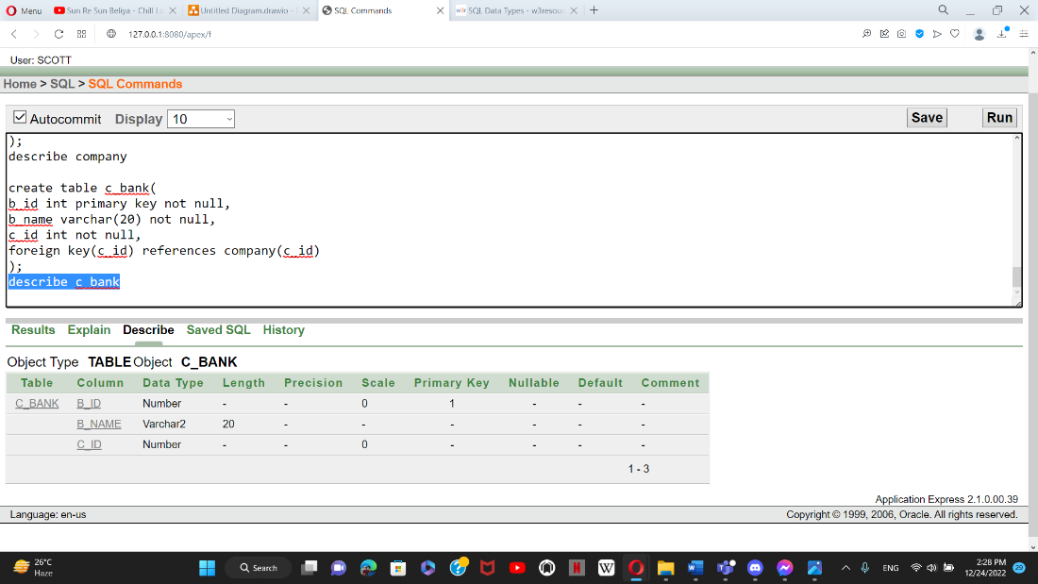

**C_EMP:**

CREATE TABLE c_emp (

e_id INT PRIMARY KEY NOT NULL,

e_name VARCHAR(20) NOT NULL,

salary int not null,

c_id int not null,

foreign key (c_id) references company(c_id)

);

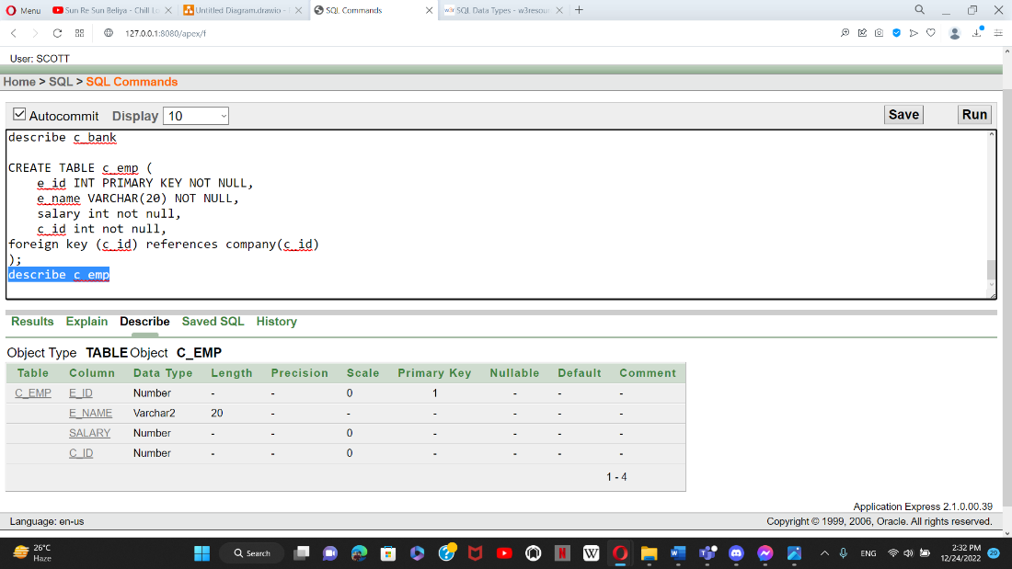

**VALUE INSERTION**

**COUNTRY TABLE INSERTION:**

INSERT INTO country VALUES ('Dhaka', 'Bangladesh');

INSERT INTO country VALUES ('Chittagong', 'Bangladesh');

INSERT INTO country VALUES ('Rajshahi', 'Bangladesh');

INSERT INTO country VALUES ('Foridpur','Bangladesh');

INSERT INTO country VALUES ('Dinajpur','Bangladesh');

**TABLE:**

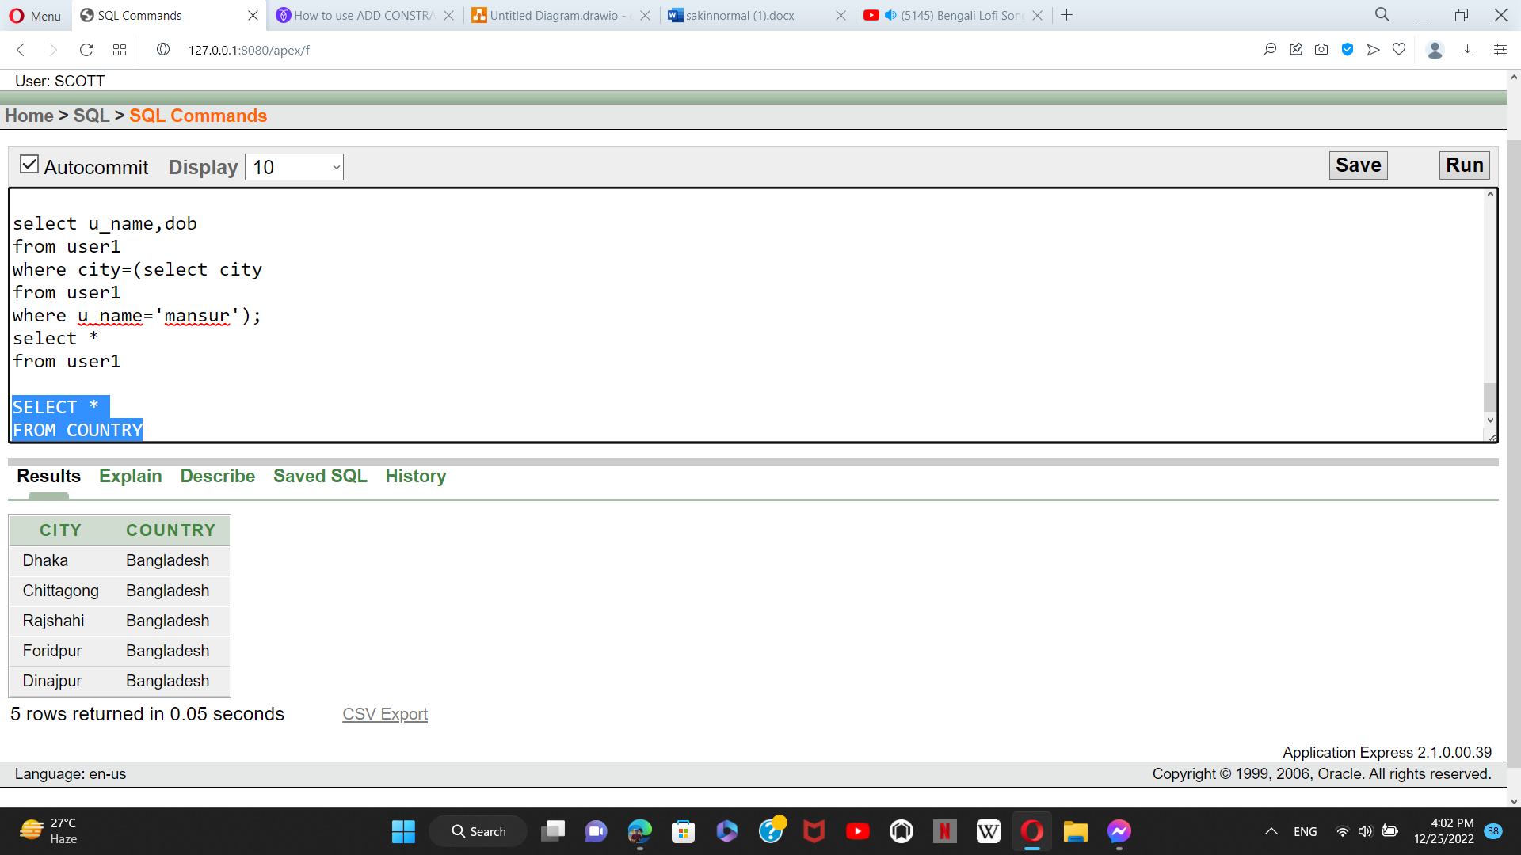

**USER1 TABLE INSERTION:**

INSERT INTO User1 VALUES (12345,'shafin','01755827777','Dhaka','12-DEC-1996');

INSERT INTO User1 VALUES (13254, 'mansur','01785548458','Dhaka','11-JAN-1995');

INSERT INTO User1 VALUES (32512,'bushra','01856482557','Foridpur', '17-DEC-1998');

INSERT INTO User1 VALUES (12534,'shakib','01722833554','Dinajpur', '30-SEP-1998');

**TABLE:**

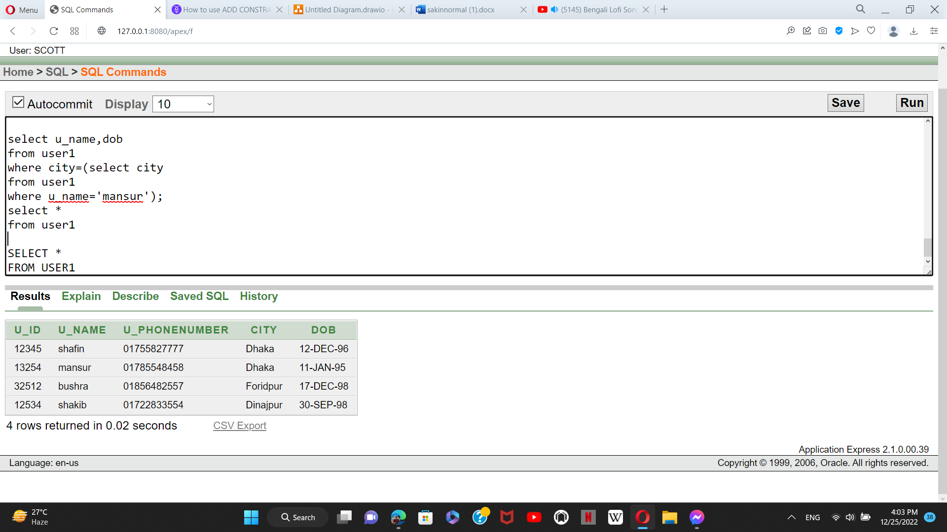

**AGENT TABLE INSERTION:**

INSERT INTO agent VALUES (12586,'01879556823',12345);

INSERT INTO agent VALUES (12574,'01879223556',12345);

INSERT INTO agent VALUES (12587,'01323589517',12345);

INSERT INTO agent VALUES (13584,'01235879126',32512);

**TABLE:**

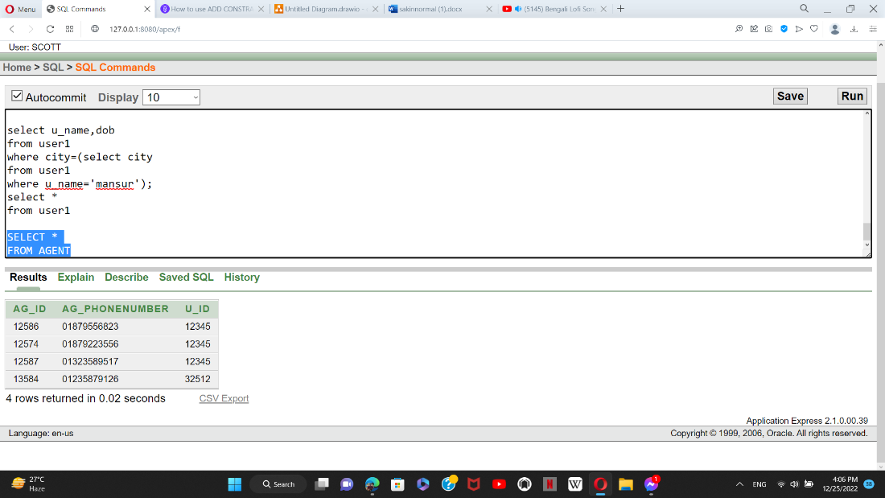

**ACCOUNT TABLE INSERTION:**

INSERT INTO account VALUES (01755827777,12345);

INSERT INTO account VALUES (01785548458,12345);

INSERT INTO account VALUES (01856482557,12345);

INSERT INTO account VALUES (01722833554,32512);

**TABLE:**

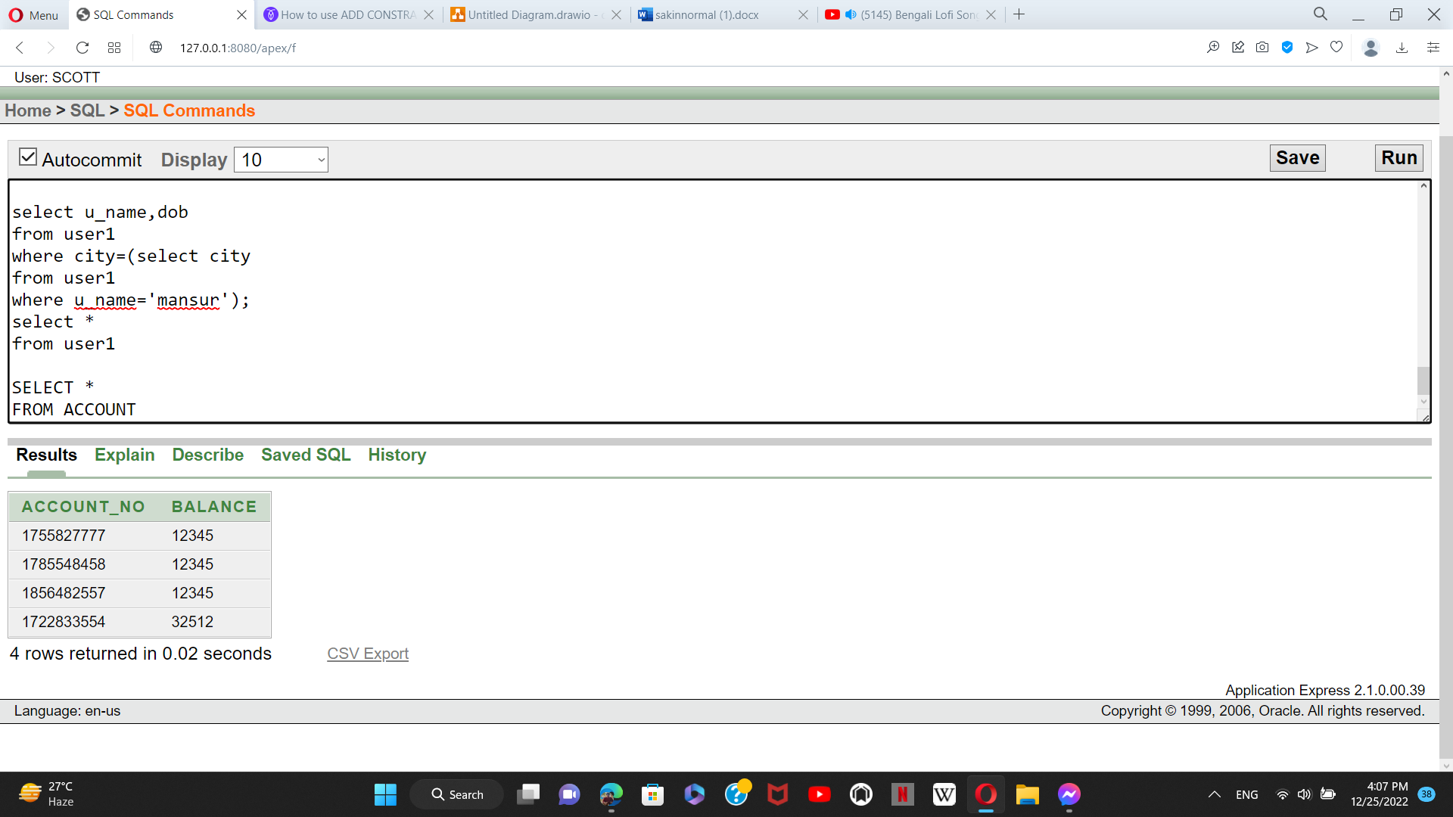

**EMPLOYEE TABLE INSERTION:**

insert into employee values(22031,'Asik ahmed',30000);

insert into employee values(22038,'Rashed Imran',25000);

insert into employee values(23049,'Aminul islam',25000);

insert into employee values(23021,'Alve Ahmed',20000);

**TABLE:**

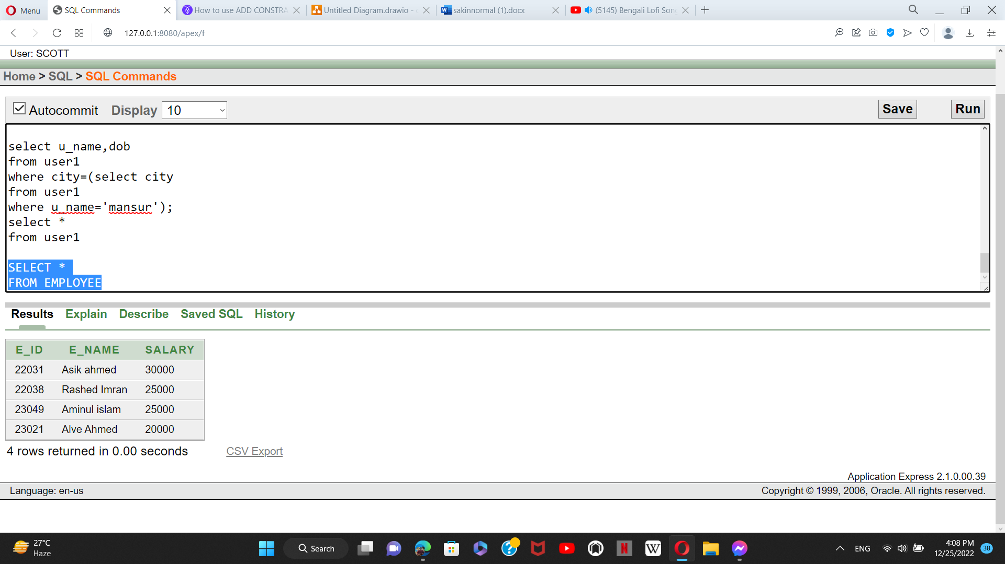

**ACC_MAINTAIN TABLE INSERTION:**

INSERT INTO acc_maintain VALUES (01755827777,22038);

INSERT INTO acc_maintain VALUES (01785548458,22038);

INSERT INTO acc_maintain VALUES (01856482557,22031);

INSERT INTO acc_maintain VALUES (01722833554,23021);

**TABLE:**

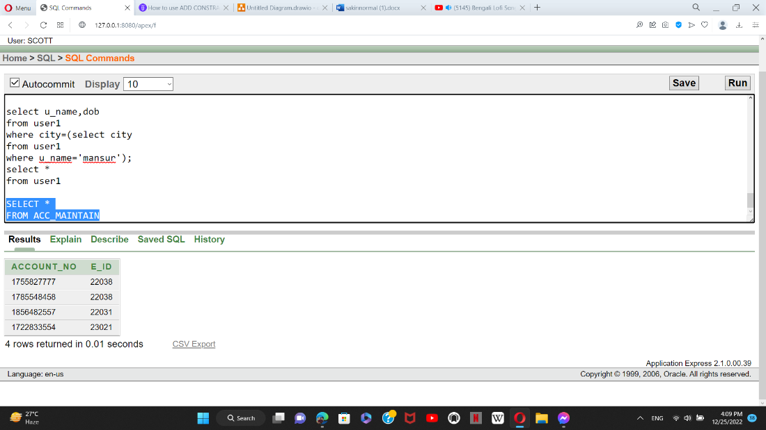

**ANOTHER_USER TABLE INSERTION:**

INSERT INTO another_user VALUES (15896,'prince','0187957682',12345);

INSERT INTO another_user VALUES (15836,'himel','0197922355',12345);

INSERT INTO another_user VALUES (16897,'sabbir','0162358951',12345);

INSERT INTO another_user VALUES (17865,'omi','0125587922',32512);

**TABLE:**

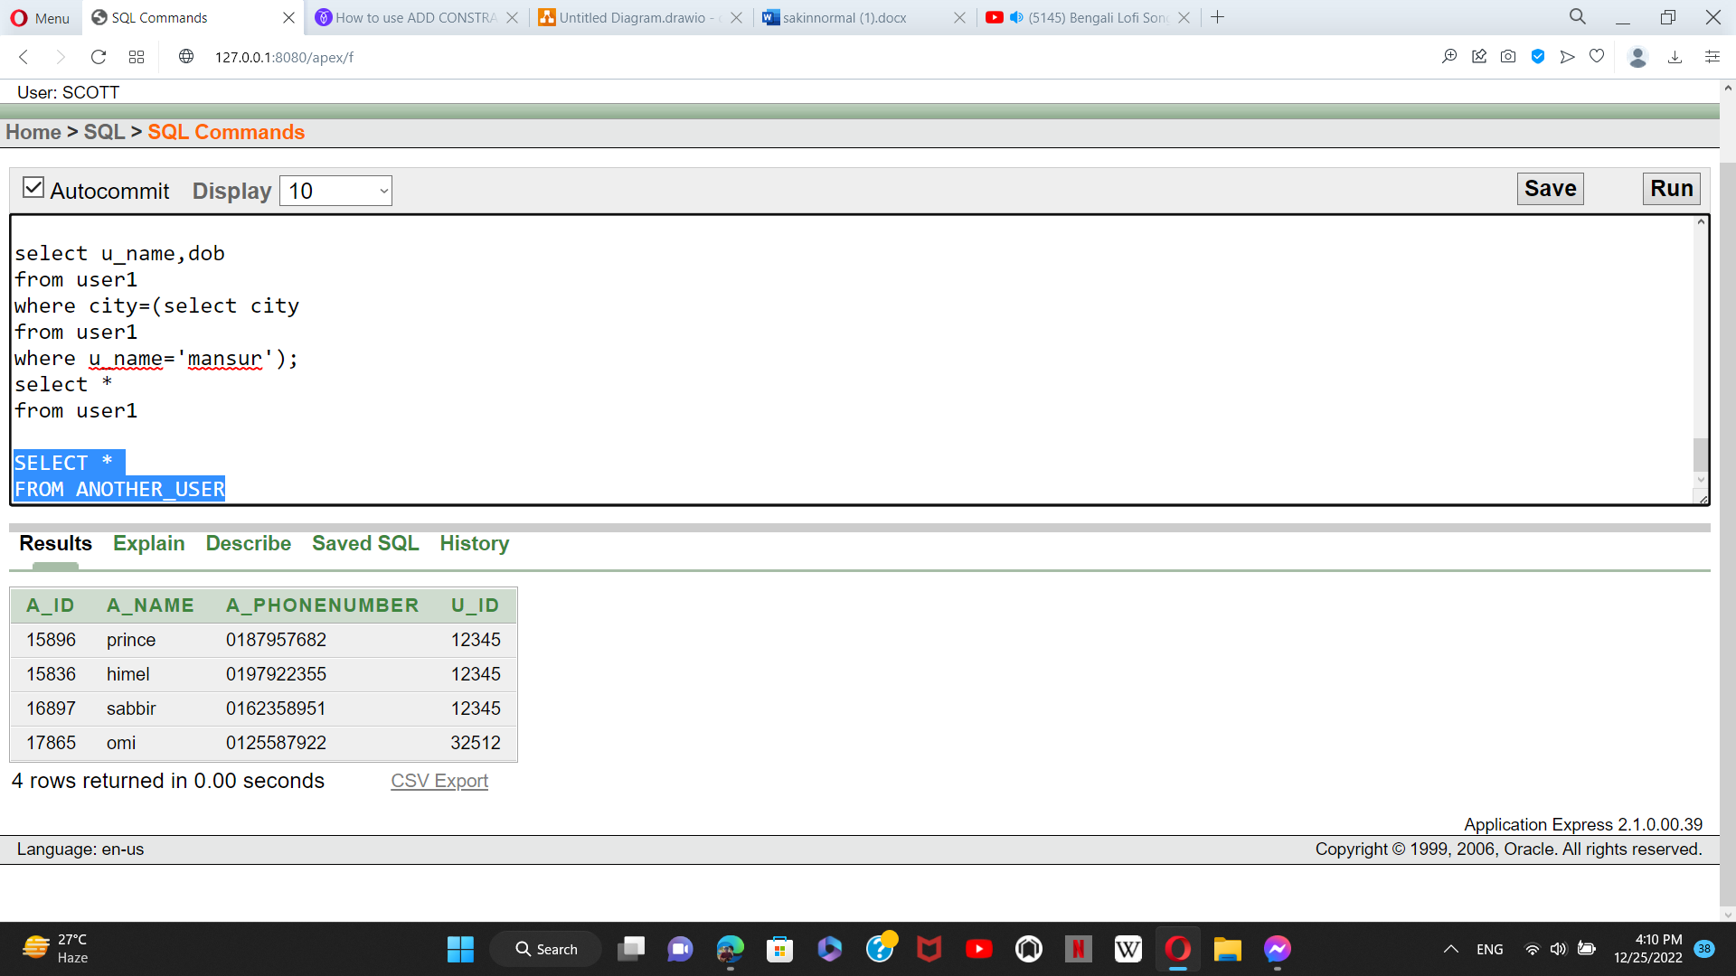

**OTHERS TABLE INSERTION:**

insert into OTHERS values(5551,'Internet');

insert into OTHERS values(5552,'Education');

insert into OTHERS values(5553,'Electricity');

insert into OTHERS values(5554,'Hospital');

**TABLE:**

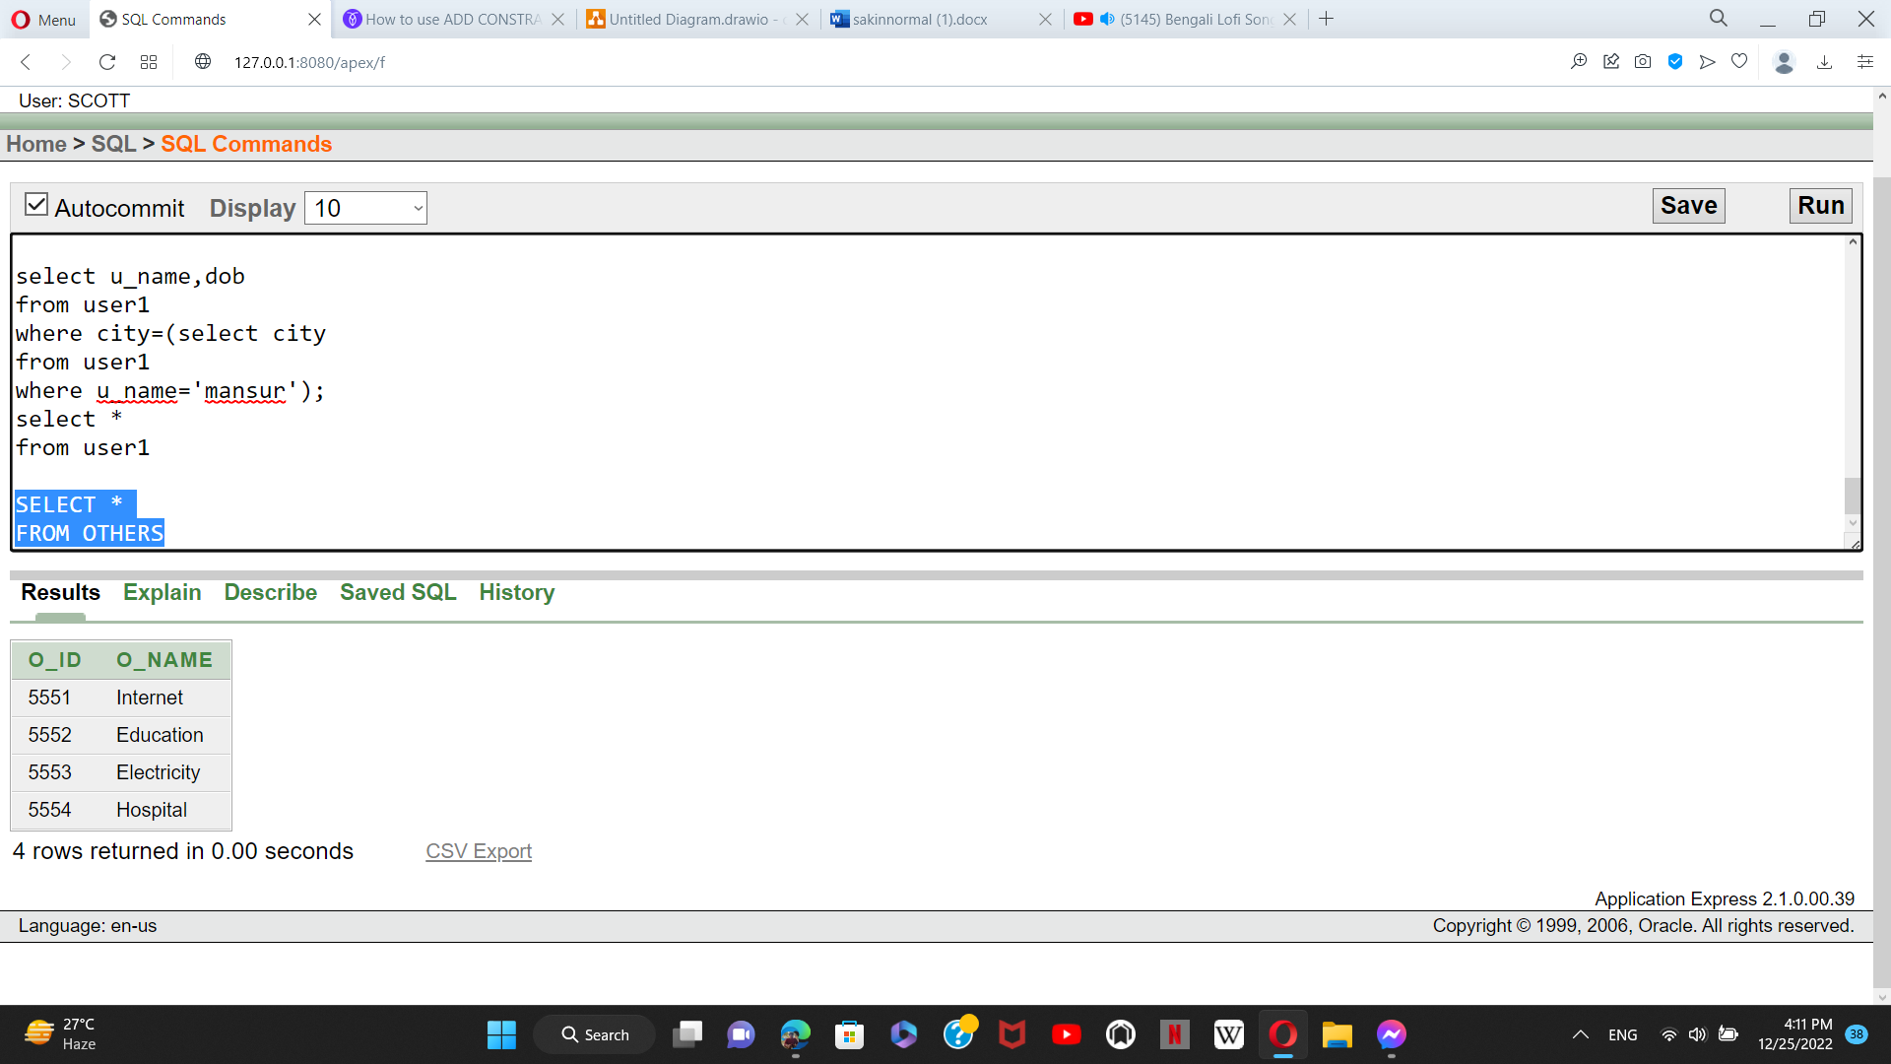

**USER_PAYBILL TABLE INSERTION:**

insert into USER_PAYBILL values(12345,5551);

insert into USER_PAYBILL values(13254,5551);

insert into USER_PAYBILL values(32512,5551);

insert into USER_PAYBILL values(12534,5552);

**TABLE:**

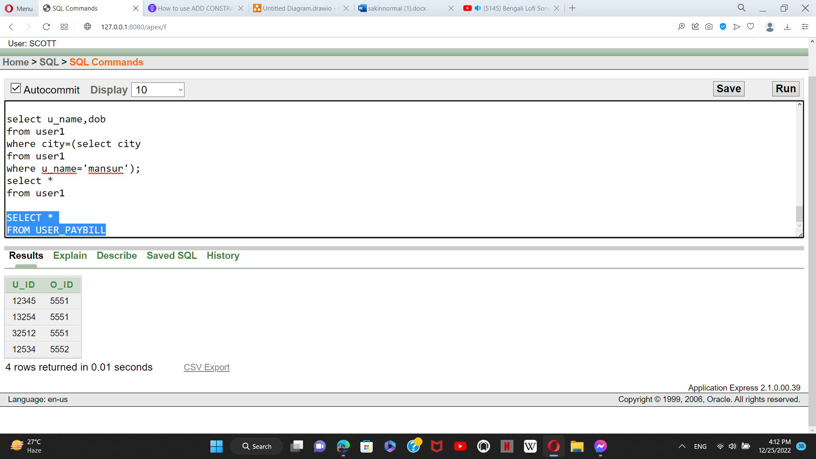

**SHOPS TABLE INSERTION:**

insert into SHOPS values(1111,'Nike');

insert into SHOPS values(1112,'Adidas');

insert into SHOPS values(1113,'Daraz');

insert into SHOPS values(1114,'Star Tech');

**TABLE:**

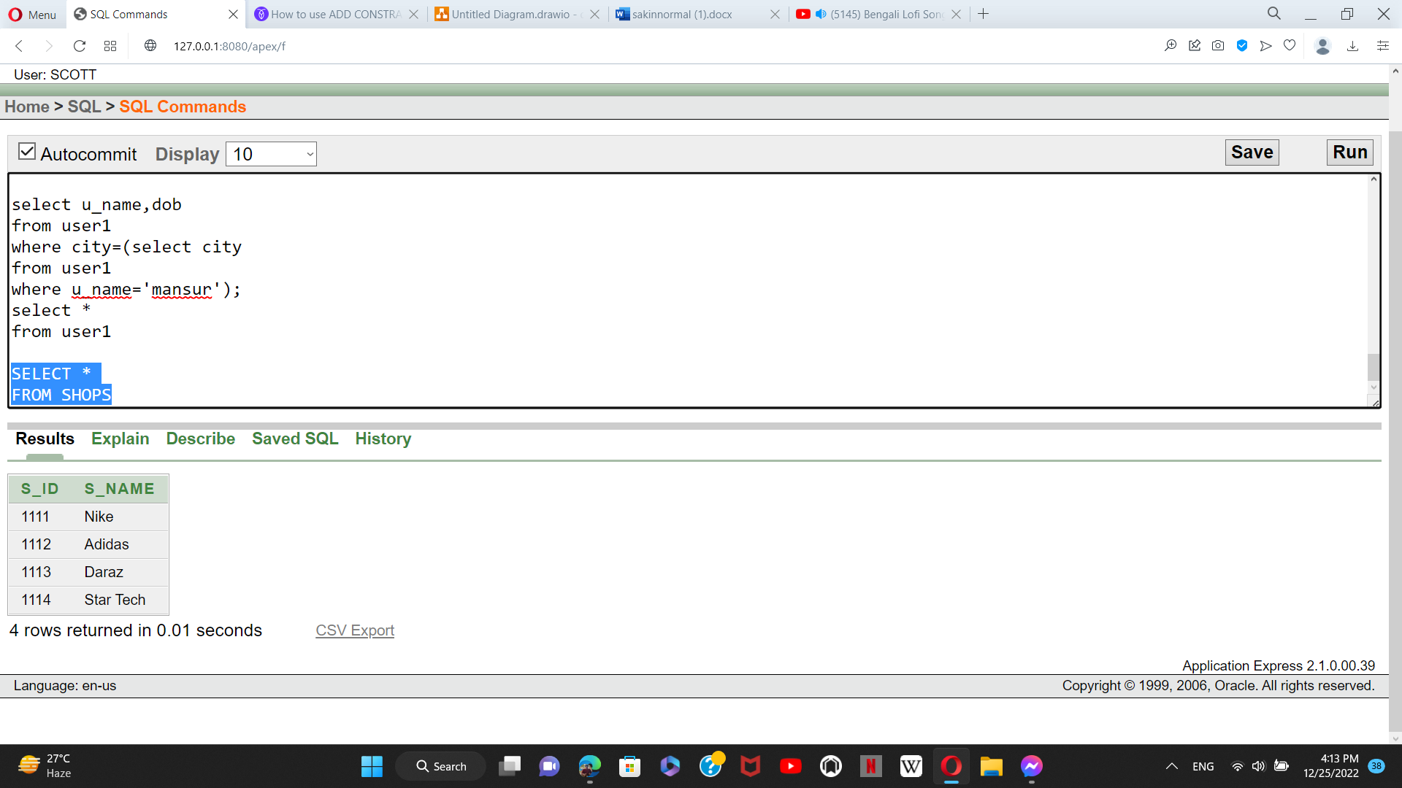

**USER_PAYMENT TABLE INSERTION:**

insert into USER_PAYMENT values(12345,1111);

insert into USER_PAYMENT values(32512,1111);

insert into USER_PAYMENT values(12534,1112);

insert into USER_PAYMENT values(13254,1112);

**TABLE:**

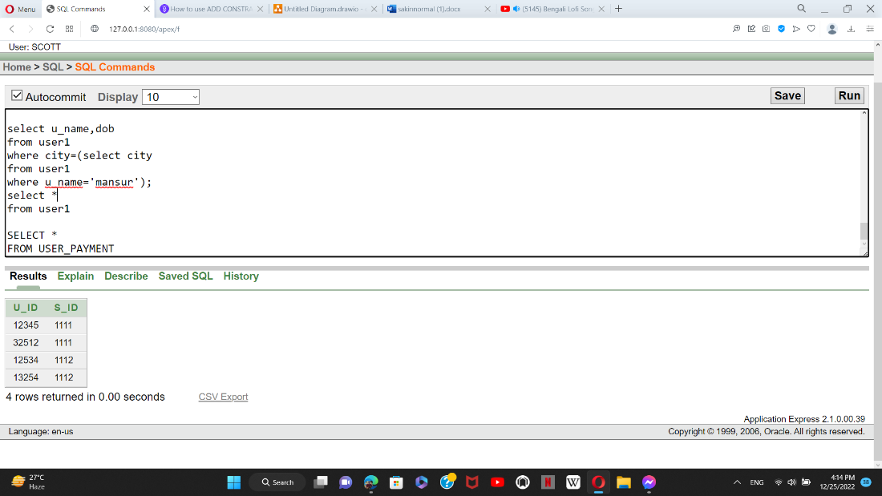

**USER_LOGIN TABLE INSERTION:**

insert into USER_LOGIN values(01755827777,2000,12345);

insert into USER_LOGIN values(01785548458,10000,13254);

insert into USER_LOGIN values(01856482557,300,12534);

insert into USER_LOGIN values(01722833554,5000,32512);

**TABLE:**

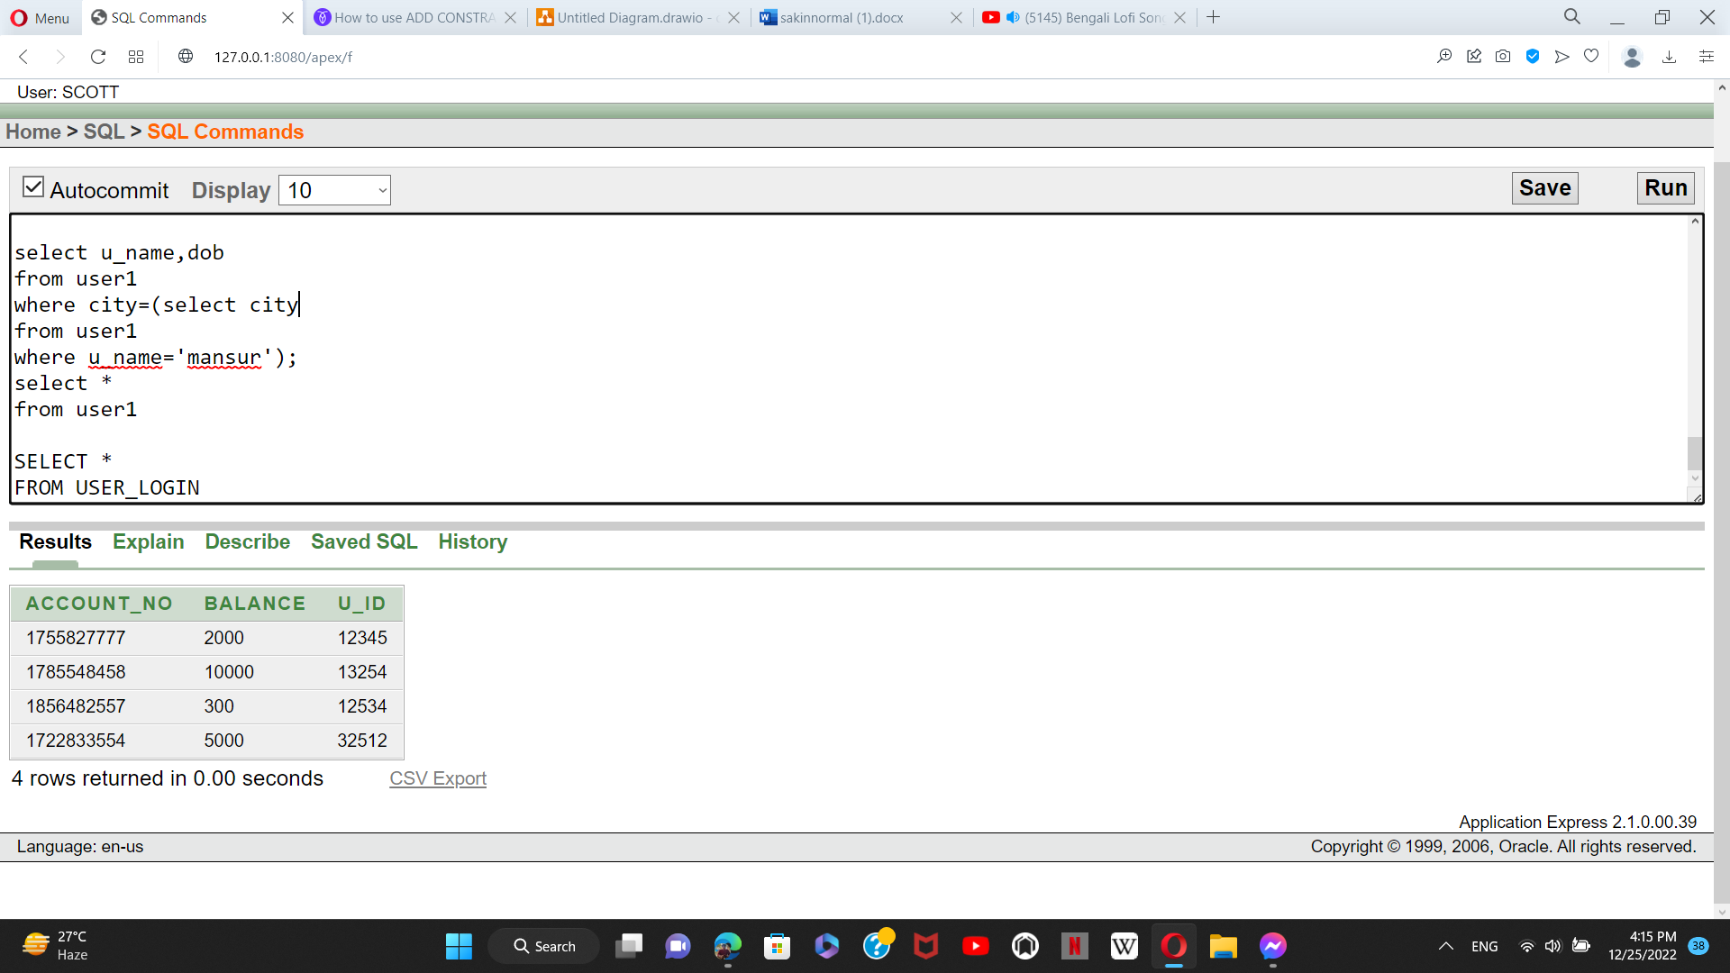

**BANK TABLE INSERTION:**

insert into BANK values(2212,'Trust Bank',01755827777);

insert into BANK values(2246,'Brac Bank',01785548458);

insert into BANK values(2266,'UCB Bank',01856482557);

insert into BANK values(2229,'Dhaka Bank',01722833554);

**TABLE:**

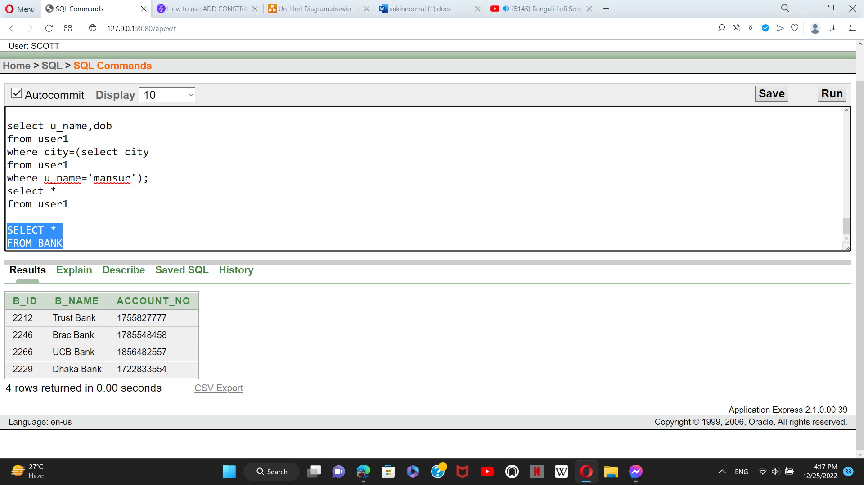

**COMPANY TABLE INSERTION:**

insert into COMPANY values(221,'bkash','Dhaka');

insert into COMPANY values(222,'Nagad','Dhaka');

insert into COMPANY values(223,'Tap','Dhaka');

insert into COMPANY values(224,'DBMB','Dhaka');

**TABLE:**

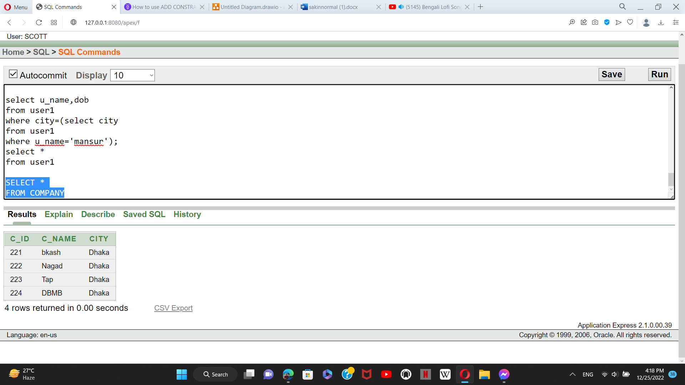

**C_BANK TABLE INSERTION:**

insert into C_BANK values(2212,'Trust Bank',221);

insert into C_BANK values(2246,'Brac Bank',221);

insert into C_BANK values(2266,'UCB Bank',222);

insert into C_BANK values(2229,'Dhaka Bank',222);

**TABLE:**

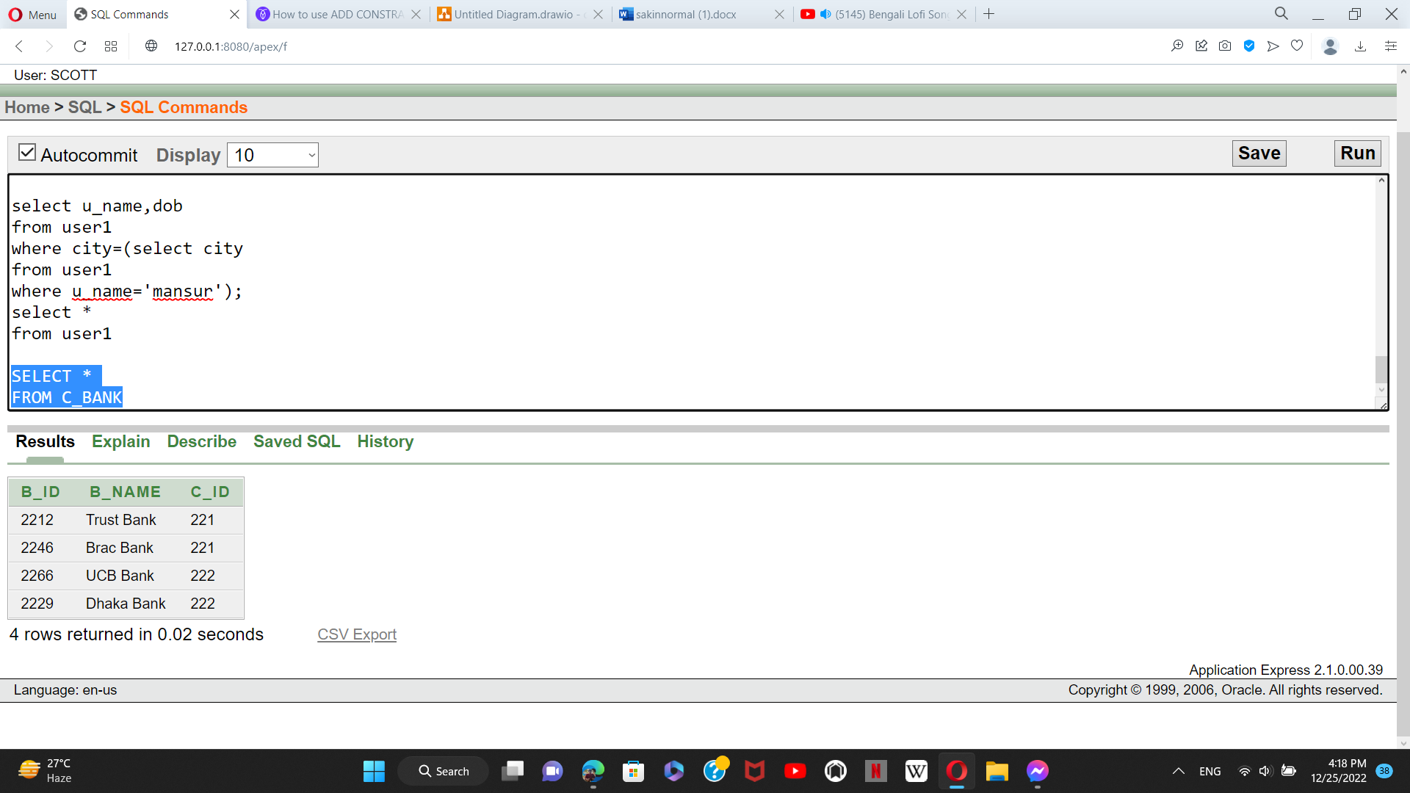

**C_EMP TABLE INSERTION:**

insert into C_EMP values(22031,'Asik ahmed',30000,221);

insert into C_EMP values(22038,'Rashed Imran',25000,221);

insert into C_EMP values(23049,'Aminul islam',25000,222);

insert into C_EMP values(23021,'Alve Ahmed',20000,222);

**TABLE:**

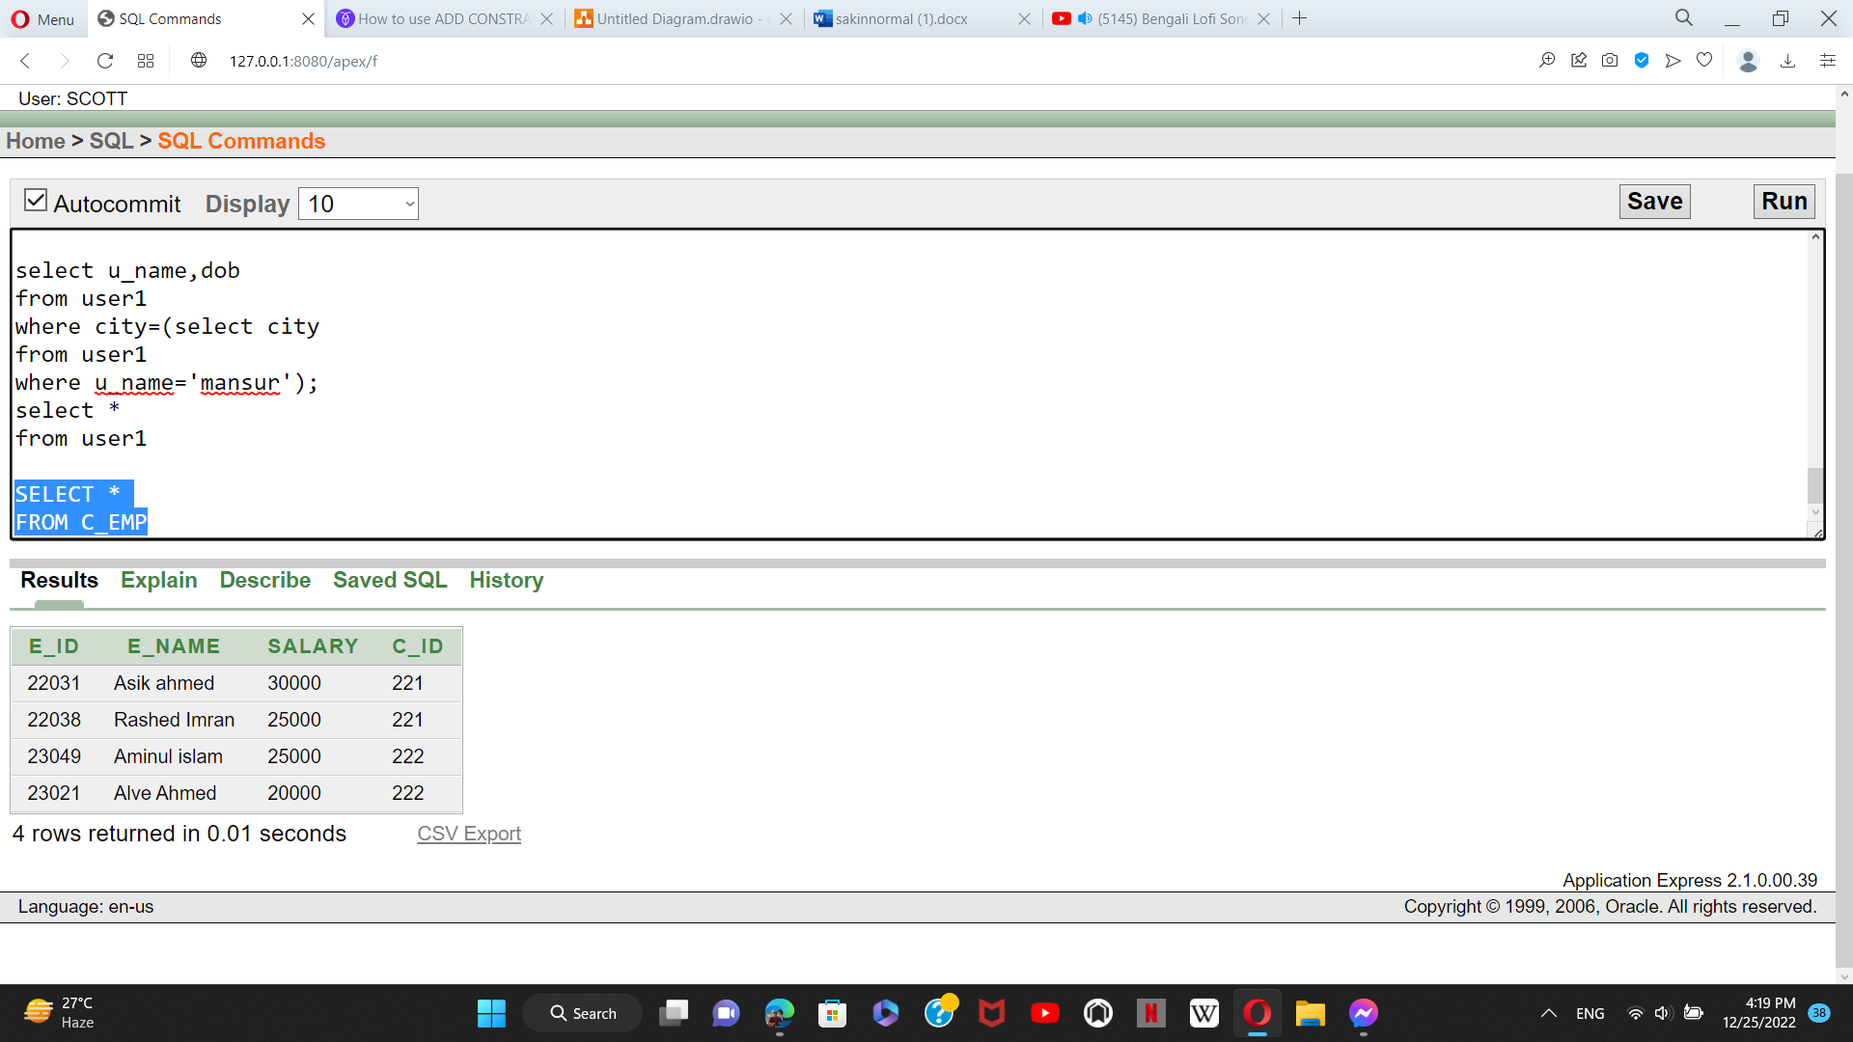

**QUERIES**

**SIMPLE QUERIES:**

1. Display all the user information by using sql queries

**Select \***

**From user1;**

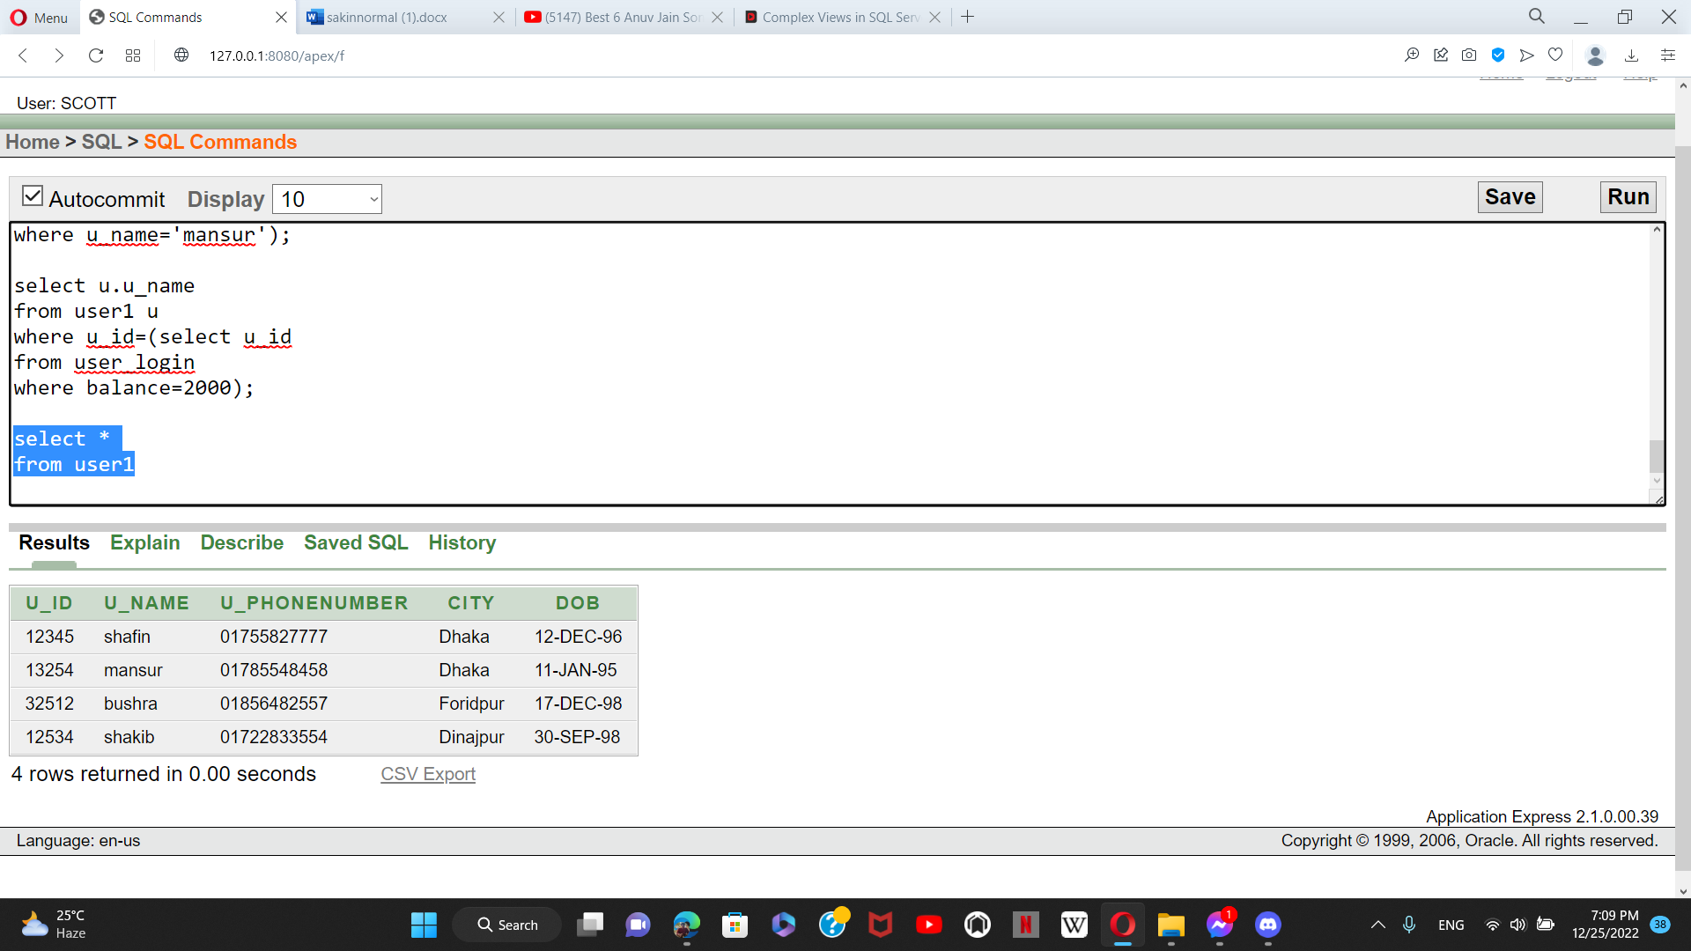

1. Display all the company information by using sql queries

**Select \***

**From company**

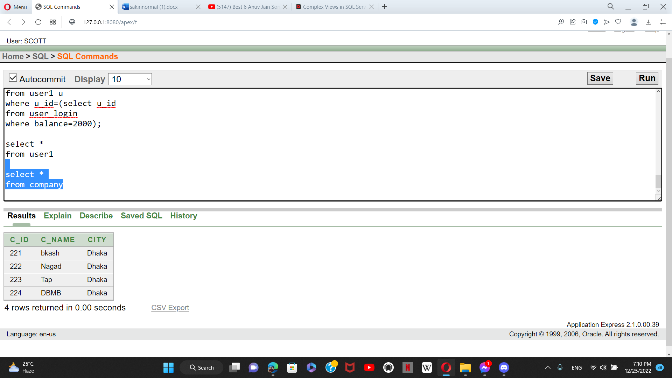

**JOINING QUERIES:**

1. **Self join:**

**Create a query which appears like ‘shakib live in dinajpur’ by using self joining**

**select a.u_name ||' live in '|| a.city as user_location**

**from user1 a, user1 b**

**where a.u_id=b.u_id**

**order by a.u_name;**

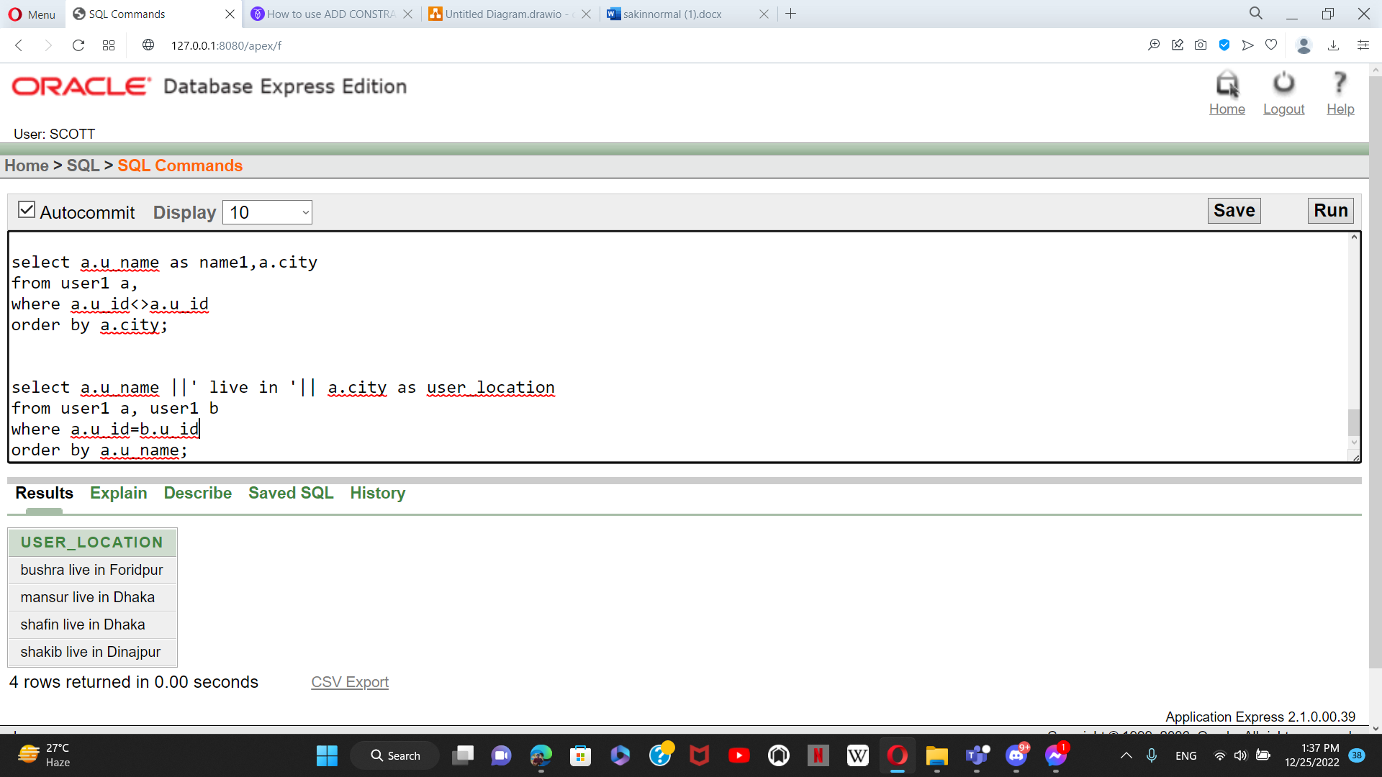

**2. Equijoin:**

**Create a join to display user id, user name, user phonenumber, user date of birth, user city, user account number, and user balance from user1 table and user_login table.**

**select u.u_id,u.u_name,u.u_phonenumber,u.dob,u.city,l.account_no,l.balance**

**from user1 u, user_login l**

**where u.u_id=l.u_id;**

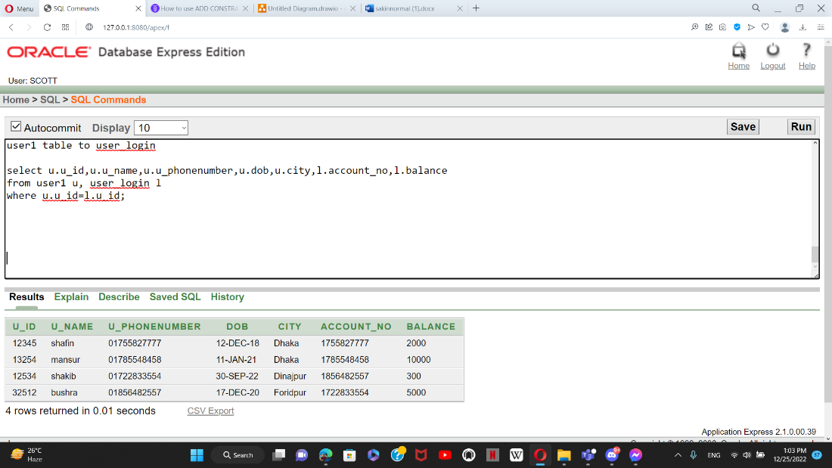

3.**OUTHER JOIN**

**Create a query to join user account number, and bank name from account table**

**select account.account_no, bank.b_name**

**from account**

**full outer join bank on**

**account.account_no=bank.account_no;**

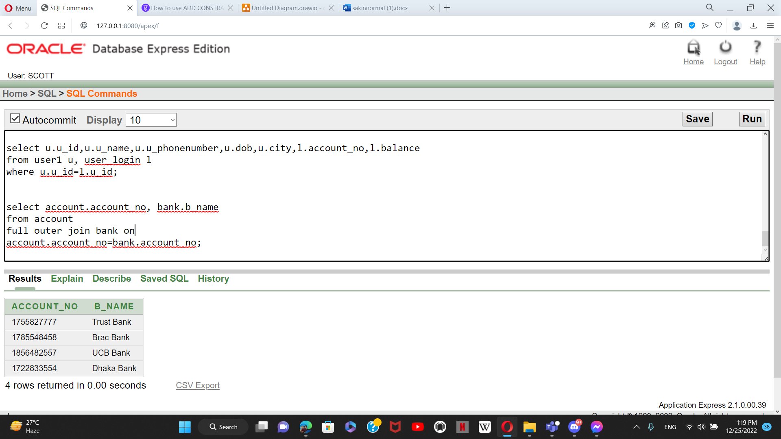

**VIEW**

1. **Simple view:**

create a view called **user_loc1** based on the user name, user date of birth, and user city from the user1 table. and their live is in dhaka city.

**create view user_loc1**

**as select u_name, dob, city**

**from user1**

**where city='Dhaka';**

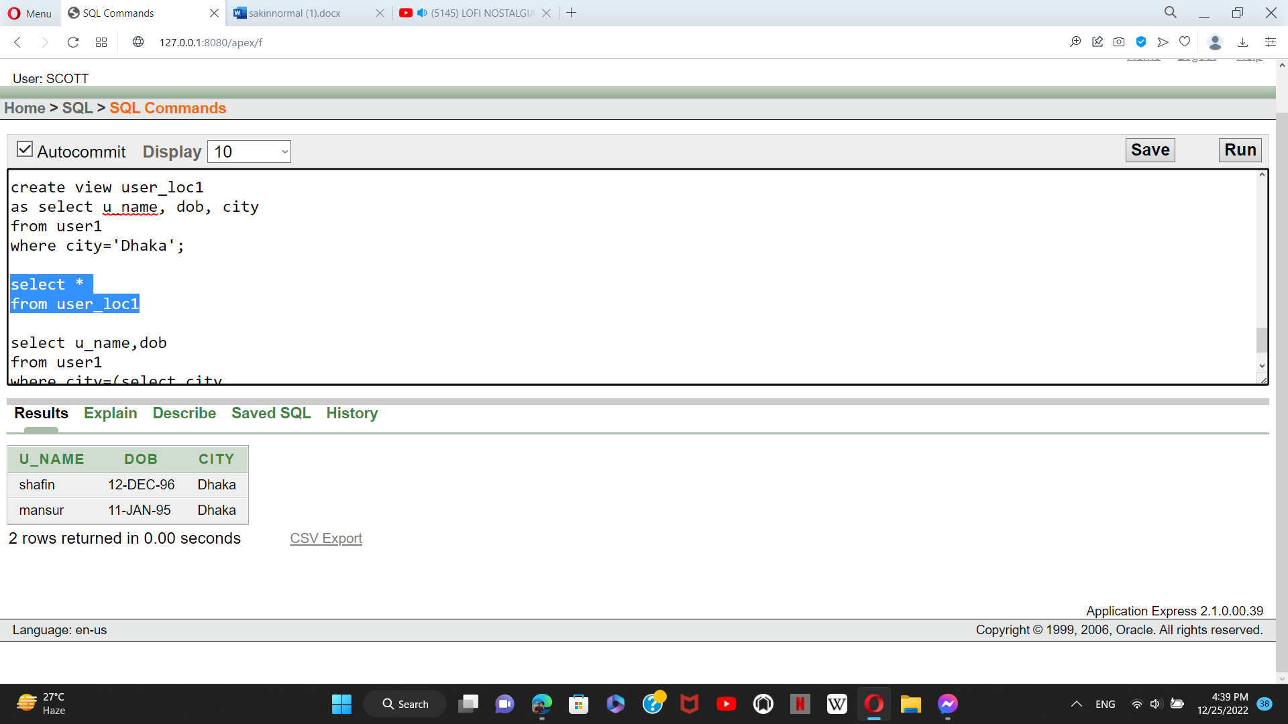

**2. c**reate a view called **user_loc3** based on the user name, user date of birth, and user living city from the user1 table. This time their living in foridpur city

**create or replace view user_loc3**

**as select u_name, dob, city**

**from user1**

**where city='Foridpur';**

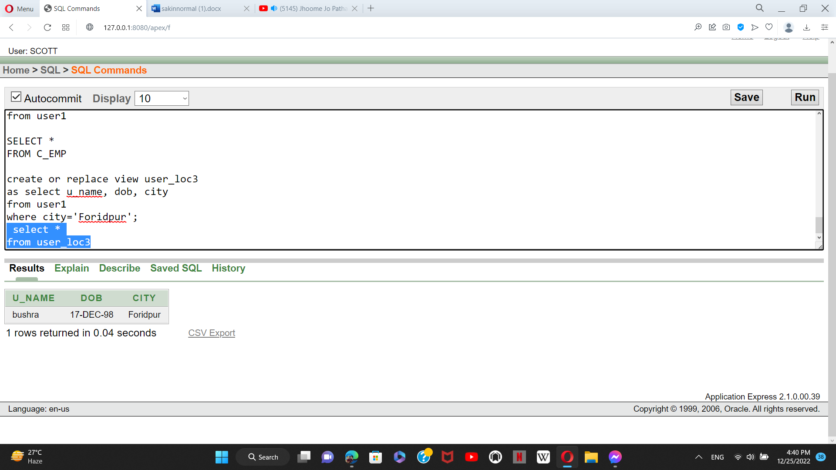

3.

create a view called **transfer** based on the account number, and bank name from account table.

**Complex view:**

**create or replace view transfer as**

**select account.account_no, bank.b_name**

**from account**

**full outer join bank on**

**account.account_no=bank.account_no;**

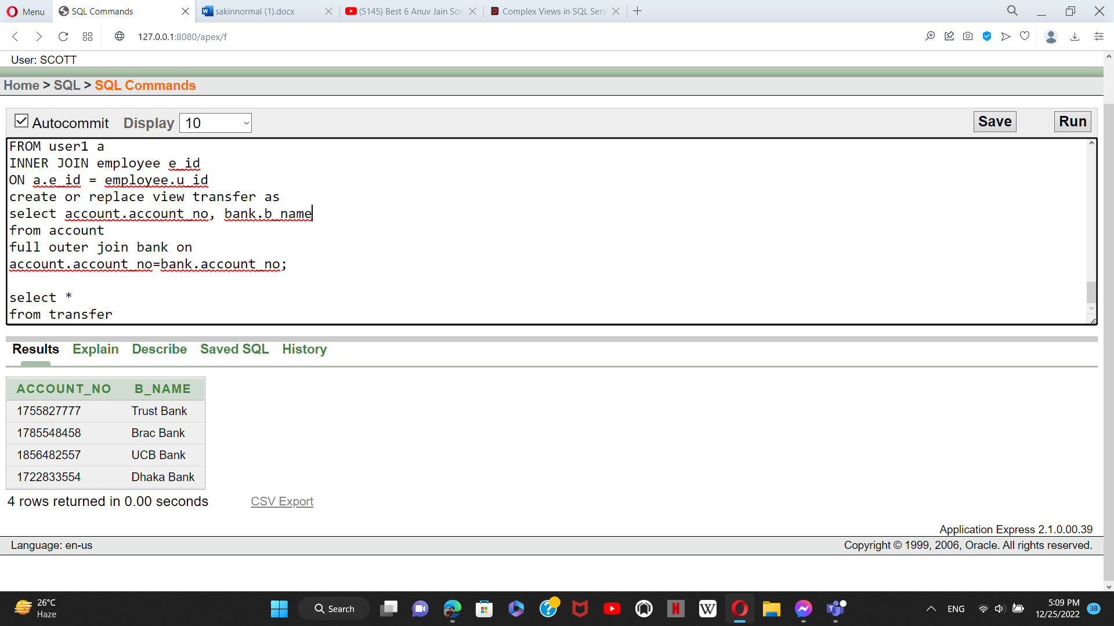

**SUBQUERY**

1.write a query to display user name and data of birth those who live in same place as mansue

**select u_name,dob**

**from user1**

**where city=(select city**

**from user1**

**where u_name='mansur');**

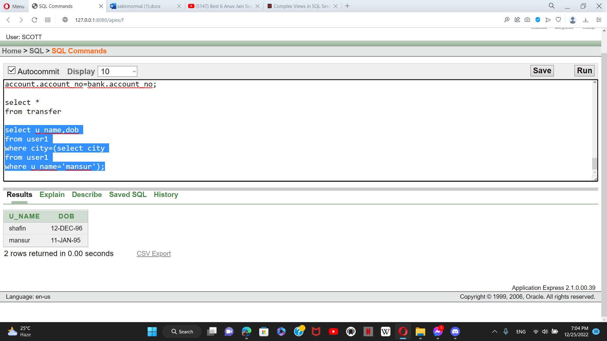

1. Write a query to display whose balance is 2000 taka in his or her account

**select u.u_name**

**from user1 u**

**where u_id=(select u_id**

**from user_login**

**where balance=2000);**

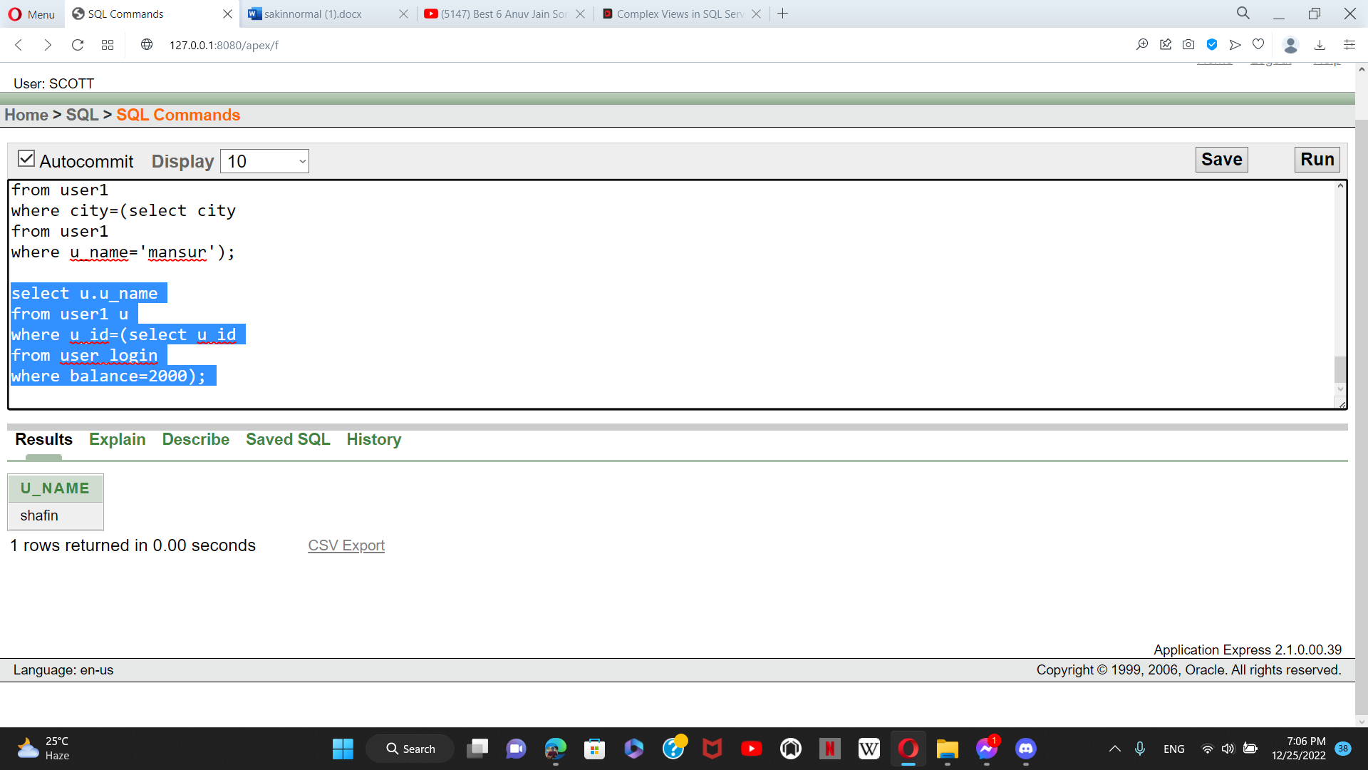

CONSTRAINTS ADDING

**CREATE TABLE User1 (**

**u_id INT PRIMARY KEY NOT NULL,**

**u_name VARCHAR(20) NOT NULL,**

**u_phonenumber VARCHAR(20) NOT NULL,**

**city VARCHAR(20) NOT NULL,**

**dob DATE NOT NULL,**

**);**

**ALTER TABLE USER1**

**ADD FOREIGN KEY (CITY) REFERENCES COUNTRY(CITY);**

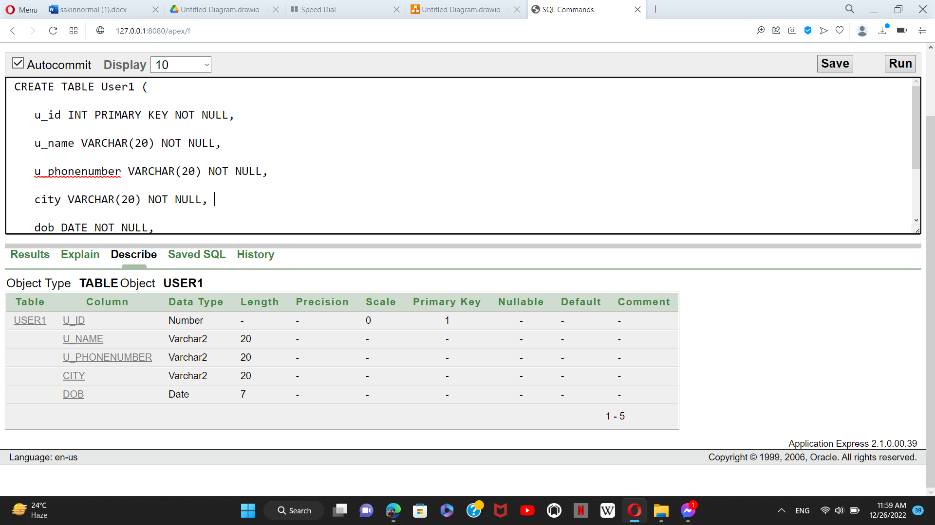

SEQUENCE

**1.**

**create sequence USER34**

**start with 1**

**increment by 1**

**maxvalue 500**

**NOCACHE**

**NOCYCLE**

